WHIM

**Table of contents**

Inception 4

Project Charter 4

Student Project Specification 6

Team Charter 7

Analysis Phase 9

Agile Backlog Template 9

Agile Iteration #1 plan 10

Agile release summary 11

State Machine Diagram 12

Use case Descriptions 12

Use Case Diagram 20

Class Diagram 23

System Sequence Diagram 24

Design Phase 24

Class Diagram 24

Data Dictionary 24

Entity Relationship Diagram 26

Navigation Diagram 27

Sequence Diagram 27

Application Prototype 28

Construction Phase 34

Agile Iteration Summary 34

unit Test Plan and Results 35

Transition Phase 39

Agile Backlog template 39

Agile Release Summary 41

Project ID Sheet with Deployment Guide 42

User and System Test Plan and Results 43

Help And Support Tutorials 48

**Inception**

*Created with the Personal Edition of HelpNDoc:* [*Easily create Help documents*](https://www.helpndoc.com/feature-tour)

**Project Charter**

**Project Name: Whim**

## Business Purpose:

The aim of this app is to bring like-minded people together and help people share or get help on their hobbies. We will enable two types of users: users who is willing to help and user who is looking for help with their hobbies.

Ex: I wish to learn guitar, I can look for people willing to teach me on the website.

1. **Who is our targeted customer?**

The best way to do business is focus on large number of sales with minimum margin of profit per product. This will help a business grow fast, be competitive in the market and reach a wider range of customers.

We will be achieving the above goal in two ways:

(i) One best way to achieve this is to get users into monthly subscription instead of users having to buy individual contents. The monthly cost will be as low as a large pizza which everyone can afford at this point of time. It is like being able to afford one pizza in entire month.

(ii) Second way is to monetize our e-learning materials by introducing controlled and limited adds into our documented materials and videos. User gets a 70% off on the monthly cost if they choose to go with the adds. It will help both, us as a business and our users. This option will start from as low as $5/month subscription price which will make it one of the most affordable e-learning platforms in market.

The best part of Whim is it will have a vast variety of content to target every age group. E-learning courses are always affordable than a physical book and is sustainable as it does not need paper or ink. This is another way of cost cutting and making courses available for low price.

On top, we will be offering deals on high demand courses to make it easy for everyone to afford without burning a hole in their pockets. Plus, we will offer stack discount on the monthly price if someone completes more than three course in a month. This business idea will be unique and will attract more customers.

Lastly, most of our users are expected to be working professionals who are looking to upskill or students who are looking to learn new things. Those sections of the society should be able to afford the pricing we are looking to offer.

1. **Will the targeted customer be able to afford our product?**

As an online platform, our users will have the ability to use our app even from their cellphone. Every age group these days have access to a smartphone, which makes it easy for our customers to access available materials on the go.

With popular platforms like YouTube and Instagram we can easily reach a larger audience to market our awesome product. Social media adds are the best way to reach the biggest possible crowd as almost everyone uses them these days.

On top, we will reach out to the schools and offices to market our product, as those people would be our prime users. Our content will be highly tailored and filtered for best user experience. The videos with high search and views will be promoted to attract more customers.

Our main sales and marketing strategy is to offer best possible education for most affordable price, to attract biggest possible crowd with lowest profit per product instead of the opposite. For the price of one pizza or possibly a cup of coffee we offer the best education they are looking for, and that too for the entire month.

## Project Roles/Responsibilities:

1. Swagat Samal Ssamal1788@conestogac.on.ca

2. Shubham Singh Ssingh5808@conestogac.on.ca

3. Puneet Chopra Pchopra0250@conestogac.on.ca

*Kindly refer to team charter for in detailed description of member responsibilities.

## Event Table:

|  |  |  |  |  |  |  |
| --- | --- | --- | --- | --- | --- | --- |
| Event | Trigger | Source | Use  Case # | Use Case | Response | Destination |
| User wants to Register for the first time. | Register | User(Needy/Helper) | UC01 | User Register | Register page is displayed | Welcome page |
| User Login | Login | User(Needy/Helper) | UC02 | User Login | User login successful message | Landing Page |
| User wants to check help availability | Item Inquiry | Needy | UC03 | Look up item availability | Item availability details are displayed | Needy |
| User wants to post help | Add help | Helper | UC04 | Add a new item | New help posted on website | Helper |
| User wants to delete some help | Delete help | Helper | UC05 | Delete an item | Selected help is removed | Helper |

## Features List:

* Register
* Login
* Post a help
* Search a help
* Email verification

## System Objectives:

* All database transactions should take less than 20ms.
* Website should be responsive.

## Project Critical Success Factors:

A business user should always keep a track of fake or misleading helps offered on the website.

## Preliminary Technical Architecture:

Frontend tech stack:

Html, CSS, Javascript, ReactJS

Business logic:

Node.JS

Model:

MongoDB (NoSQL)

Reference: Systems Analysis and Design in a Changing World, 5e, p. 169

*Created with the Personal Edition of HelpNDoc:* [*Create iPhone web-based documentation*](https://www.helpndoc.com/feature-tour/iphone-website-generation)

**Student Project Specification**

This Letter of Understanding is entered into as of the Signing Date between the STUDENT(S) and the COMPANY for the purpose to describe the student project.

WHEREAS the STUDENT(S), enrolled at Conestoga College Institute of Technology and Advanced Learning (herein “Conestoga”), has (have) been asked to develop, design, and/or produce a prototype product or process for the COMPANY in the pursuit of either his/her/their academic requirements within a final year, capstone, or class project, or other project outside of academic pursuits (herein referred to as “PROJECT”);

AND WHEREAS the COMPANY has agreed to accept the quality and quantity of the STUDENT’s work in the pursuit of his/her/their academic requirement as presented in the final deliverable for the PROJECT and to accept the full responsibility and full risk of implementing the final deliverable into the COMPANY, the parties agree upon the following scope and schedule.

| Project Definition | |
| --- | --- |
| **Title** | Whim |
| **Description**  **(< 300 words)** | The aim of this app is to bring like-minded people together and help people share or get help on their hobbies. We will enable two types of users: users who is willing to help and user who is looking for help with their hobbies.  Ex: I wish to learn guitar; I can look for people willing to teach me on the website.  This project aims at helping communities and promoting togetherness. |
| **Short Description**  **for Conestoga Website**  **(< 150 words)** | A place where like minded people can come together, offer help, market their knowledge and grow together.  Users can either post a help or book a help from others. |
| **Deliverables** | * Project documentation * Git Repo * Fully working website |
| **Start Date** | 19th Jan 2022 |
| **End Date** | 7th April 2022 |
| **Estimated amount of work (in hours)** | 200 |
| **Budget Proposal** | Everything we will be using would be opensource |
| **Intellectual Property** |  |
| **Company In-Kind Contribution** |  |

Having read and understood this Agreement, the STUDENT(S) and the COMPANY accept the above terms and conditions as of the Signed Date.

| Student 1 | T | T | COMPANY | T |
| --- | --- | --- | --- | --- |
| **Signature:** | Swagat Samal |  | **Signature:** |  |
| **Signing Date:** | 24th Jan 2022 |  | **Signing Date:** |  |
| **Name (Printed):** | Swagat Samal |  | **Name (Printed):** |  |
| **Email:** | Ssamal1788@conestogac.on.ca |  | **Title:** |  |
|  |  |  |  | *I have authority to bind the COMPANY.* |
| Student 2 | T |  | **Name of Company:** |  |
| **Signature:** | Shubham Singh |  | **Address:** |  |
| **Signing Date:** | 24th Jan 2022 |  | **Tel:** |  |
| **Name (Printed):** | Shubham Singh |  | **Fax:** |  |
| **Email:** | [Ssingh5808@conestogac.on.ca](mailto:Ssingh5808@conestogac.on.ca) |  | **Email:** |  |
|  |  |  |  |  |
| Student 3 | T |  |  |  |
| **Signature:** | Puneet Chopra |  |  |  |
| **Signing Date:** | 24th Jan 2022 |  |  |  |
| **Name (Printed):** | Puneet Chopra |  |  |  |
| **Email:** | [Pchopra0250@conestogac.on.ca](mailto:Pchopra0250@conestogac.on.ca) |  |  |  |
|  |  |  |  |  |
| Student 4 |  |  | Witness |  |
| **Signature:** |  |  | **Signature:** |  |
| **Signing Date:** |  |  | **Signing Date:** |  |
| **Name (Printed):** |  |  | **Name (Printed):** |  |
| **Email:** |  |  |  |  |

This template-document has been developed by Conestoga’s Applied Research and Innovation office for the use in Research Projects. Conestoga is not a party to this Agreement.

*Created with the Personal Edition of HelpNDoc:* [*Full-featured multi-format Help generator*](https://www.helpndoc.com/help-authoring-tool)

**Team Charter**

## Team Name

**Code Cartel**

## Team Members

1. Swagat Samal [Ssamal1788@conestogac.on.ca](mailto:Ssamal1788@conestogac.on.ca)
2. Shubham Singh [Ssingh5808@conestogac.on.ca](mailto:Ssingh5808@conestogac.on.ca)
3. Puneet Chopra [Pchopra0250@conestogac.on.ca](mailto:Pchopra0250@conestogac.on.ca)
4. Michael Stacey Mstacey@conestogac.on.ca

## Member Roles

List the team member(s) who will work on each aspect of the project in the table below:

|  |  |
| --- | --- |
| Project Management | |
| Team leadership | Swagat |
| Project planning | Michael, Swagat, Shubham, Puneet |
| Project record-keeping | Swagat, Shubham, Puneet |
| Analysis, Design and Documentation | |
| Interacting with clients | Puneet |
| Diagramming and documenting client requirements | Shubham |
| Diagramming and documenting overall design | Swagat |
| Technical documentation | Shubham |
| Client documentation | Puneet |
| Web Development | |
| Creating web graphics | Puneet, Swagat |
| Web site design | Swagat, Shubham, Puneet |
| Web page design | Shubham |
| Web programming | Swagat, Shubham, Puneet |
| Interactive testing | Puneet |
| Business Layer Development | |
| Class design | Puneet |
| Business programming | Swagat, Shubham |
| Technical / lower-level programming | Swagat, Shubham, Puneet |
| Unit and integration testing | Shubham |
| Database Development | |
| Database design | Puneet |
| SQL/LINQ Development | Shubham |
| Other | |
| Report development | Michael, Puneet |
| Installer development | Swagat, Shubham |

## Expectations

We expect every team member to show up on time for all Agile meetings as we would be following Agile methodologies to accomplish this task. Also, everyone is expected to finish their assigned tasks within the assigned sprint. Our sprint will last for a week.

## Consequences

If expectations are not met than it will be reported to project coordinator, and he/she will be taking the necessary actions. And as a team we will try to motivate each other to give our best to achieve the expected outcomes as a team

## Agreement

Shubham Singh

Puneet Chopra

Swagat Samal

*Created with the Personal Edition of HelpNDoc:* [*Produce electronic books easily*](https://www.helpndoc.com/create-epub-ebooks)

**Analysis Phase**

*Created with the Personal Edition of HelpNDoc:* [*Free EPub and documentation generator*](https://www.helpndoc.com)

**Agile Backlog Template**

|  |  |  |  |  |  |  |
| --- | --- | --- | --- | --- | --- | --- |
| **Conestoga College** | |  |  |  |  |  |
| **Team:** | Student A, Student B |  |  |  |  |  |
|  |  |  |  |  |  |  |
| **Agile Product Feature List - Backlog Template** | |  |  |  |  |  |
|  |  |  |  |  |  |  |
| **#** | **Description** | **PD est.** | **By** | Note: PD = Person day = 4 hours; start feature # from 101 (reserve 1-100 for other requirements) | | |
|  |  |  |  |  |  |  |
|  | **High Priority** |  |  | Note: Only high priority items are prioritized, assigned to iteration, and estimated | | |
|  | Iteration 1 |  |  |  |  |  |
| 3 | Design User Registration Page |  | 4 |  |  |  |
| 5 | Design Login Page |  | 4 |  |  |  |
|  |  |  |  |  |  |  |
|  | Iteration 2 |  |  |  |  |  |
| 8 | Database design |  |  | 6 |  |  |
| 10 | Wireframe and Prototyping |  |  | 8 |  |  |
|  |  |  |  |  |  |  |
|  | Iteration 3 |  |  |  |  |  |
| 12 | Implement Place order |  |  |  | 6 |  |
| 13 | Design Landing Page |  |  |  | 8 |  |
| 16 | Unit Test and result |  |  |  | 10 |  |
|  |  |  |  |  |  |  |
|  |  |  |  |  |  |  |
|  |  |  |  |  |  |  |
|  | **Medium Priority** |  |  | Note: Medium and Low are prioritized but not yet assigned to iteration, nor estimated | | |
|  | Iteration 1 |  |  |  |  |  |
| 4 | Implement Email Verification |  | 4 |  |  |  |
| 7 | Agile Iteration plan |  | 4 |  |  |  |
|  |  |  |  |  |  |  |
|  | Iteration 2 |  |  |  |  |  |
| 11 | Entity Relationship Diagram |  |  | 4 |  |  |
|  |  |  |  |  |  |  |
|  | Iteration 3 |  |  |  |  |  |
| 14 | Implement Order Confirmation |  |  |  | 4 |  |
| 15 | Implement fake payment page |  |  |  | 6 |  |
| 17 | Working code demo |  |  |  | 2 |  |
|  |  |  |  |  |  |  |
|  |  |  |  |  |  |  |
|  |  |  |  |  |  |  |
|  |  |  |  |  |  |  |
|  | **Low Priority** |  |  |  |  |  |
|  | Iteration 1 |  |  |  |  |  |
| 6 | UML Diagrams |  | 6 |  |  |  |
|  |  |  |  |  |  |  |
|  |  |  |  |  |  |  |
|  | Iteration 2 |  |  |  |  |  |
| 9 | Design Mock Data |  |  | 6 |  |  |
|  |  |  |  |  |  |  |
|  |  |  |  |  |  |  |
|  | Iteration 3 |  |  |  |  |  |
| 17 | Working code demo |  |  |  | 2 |  |
| 19 | Implement Logger |  |  |  |  | 16 |

*Created with the Personal Edition of HelpNDoc:* [*Easily create HTML Help documents*](https://www.helpndoc.com/feature-tour)

**Agile Iteration #1 plan**

**Agile Iteration #1 Plan Guide**

The point of the Iteration Plan is to have a goal to be set for each iteration that can be assessed at the end of each iteration. Iteration Plans should be created at the start of each iteration (week 4, week 7 and week 10). Iteration Plans can repeat work items if necessary (i.e., if a planned work item is not completed in Iteration 1, it can then be included in Iteration 2).

**Iteration Plan**

1. What work items did the team plan to complete by the end of the iteration 1)?

* Use case diagram
* Project setup
* Analysis Level Class Diagram
* System Sequence Diagram
* State Chart Diagram
* Design login page
* Design Registration page
* Email Validation for registration
* Design Database

**Q:** Did Iteration Plan include other work items (e.g., setup development environment, bug fixing) in the Iteration backlog list?

**Ans:** Yes, setup development environment is included in this phase.

1. Are the work items for this iteration included on this iteration's agile release summary?

**Ans:** Yes.

1. Coordination Meetings

* Expected number of coordination team meetings: 5 per week
* Expected time per meeting: 15 minutes

1. Did the team verify the architecture early?

**Ans:** Our product is on analysis phase, and we are working on designing the most efficient architecture. The report will be included in next phase.

1. Did the team visually track progress (E.g., Trello)? What software tool was used (if whiteboard was used, take snapshots using a phone camera, etc.)? Did the visual tracking help the team?

**Ans:** We are using Azure DevOps to tract our progress – documents, codes, and work items.

**Link to private repository:** https://dev.azure.com/capstoneTeam6/Whim

1. Did the team prepare burn down charts? (at a minimum, update the chart weekly and show progress to advisor)

**Ans:** Yes, we have that option on Azure DevOps and we will be sharing the report to our advisor.

*Created with the Personal Edition of HelpNDoc:* [*Full-featured Kindle eBooks generator*](https://www.helpndoc.com/feature-tour/create-ebooks-for-amazon-kindle)

**Agile release summary**

|  |  |  |  |  |  |  |  |  |
| --- | --- | --- | --- | --- | --- | --- | --- | --- |
| **Conestoga College** | |  |  |  |  |  |  |  |
|  |  |  |  |  |  |  |  |  |
| **Team:** | Michael Stacey, Swagat Samal, Puneet Chopra, Shubham Singh | |  |  |  |  |  |  |
|  |  |  |  |  |  |  |  |  |
| **Release Plan Summary** | |  |  |  |  |  |  |  |
|  |  |  |  |  |  |  |  |  |
|  |  | **Inception** | **Iteration #1** | **Iteration #2** | **Iteration #3** | **Transition** |  |  |
|  |  | Due: Jan-23 | Due: Feb-13 | Due: Mar-13 | Due: Apr-3 | Due: Apr-24 |  |  |
| **#** | **Feature / Requirement** |  |  |  |  |  |  |  |
| 1 | Project Charter | 2 |  |  |  |  |  |  |
| 2 | Team Charter | 2 |  |  |  |  |  |  |
| 3 | Design User Registration Page |  | 4 |  |  |  |  |  |
| 4 | Implement Email Verification |  | 4 |  |  |  |  |  |
| 5 | Design Login Page |  | 4 |  |  |  |  |  |
| 6 | UML Diagrams |  | 6 |  |  |  |  |  |
| 7 | Agile Iteration plan |  | 4 |  |  |  |  |  |
| 8 | Database design |  |  | 6 |  |  |  |  |
| 9 | Design Mock Data |  |  | 6 |  |  |  |  |
| 10 | Wireframe and Prototyping |  |  | 8 |  |  |  |  |
| 11 | Entity Relationship Diagram |  |  | 4 |  |  |  |  |
| 12 | Implement Place order |  |  |  | 6 |  |  |  |
| 13 | Design Landing Page |  |  |  | 8 |  |  |  |
| 14 | Implement Order Confirmation |  |  |  | 4 |  |  |  |
| 15 | Implement fake payment page |  |  |  | 6 |  |  |  |
| 16 | Unit Test and result |  |  |  | 10 |  |  |  |
| 17 | Working code demo |  |  |  | 2 |  |  |  |
| 18 | Transition/Code documentation |  |  |  |  | 16 |  |  |
| 19 | Implement Logger |  |  |  |  | 16 |  |  |
|  |  |  |  |  |  |  |  |  |
|  |  |  |  |  |  |  |  |  |
|  |  |  |  |  |  |  |  |  |
|  |  |  |  |  |  |  |  |  |
|  | Work Effort in Person Days (PD) | 4 | 22 | 24 | 36 | 32 | **118** | Target: 135 to 150 PD for team of 3 |
|  |  |  |  |  |  |  |  | Given: 1 PD = 4 hours |
|  |  |  |  |  |  |  |  | Estimate: 3 PD per week = 45 PD per member; 135 PD for team of 3 |

*Created with the Personal Edition of HelpNDoc:* [*Produce online help for Qt applications*](https://www.helpndoc.com/feature-tour/create-help-files-for-the-qt-help-framework)

**State Machine Diagram**

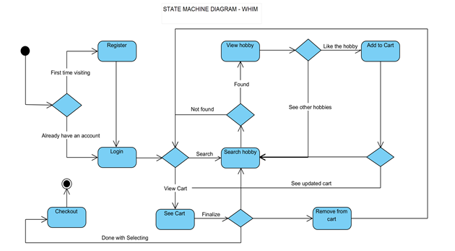

*Created with the Personal Edition of HelpNDoc:* [*Create help files for the Qt Help Framework*](https://www.helpndoc.com/feature-tour/create-help-files-for-the-qt-help-framework)

**Use case Descriptions**

|  |  |  |
| --- | --- | --- |
| Use Case # | **1** | |
| Use Case Name | **User Login** | |
| Scenario | Registered user access his/her account | |
| Triggering Event |  | |
| Brief Description | When a user wants to get the full access of the web application, he/she has to login to the web application first. | |
| Actors | User, Server | |
| Related Use Cases | Registration | |
| Stakeholders | User, Server, System | |
| Pre-conditions | User must be already registered | |
| Post-conditions | User should have the valid Login credentials | |
| Flow of Events | **Actor** | **System** |
| 1.1 User tries to login  1.3 Server Verifies the user details  1.5 User Gets success full message | 1.2 System send entered credentials to Server  1.4 System allows the user to access the account |
| Exception  Conditions | 1. Users enter wrong details  3. Server verifies the user details  5. User gets error message. | 2. System send entered credentials to Server  4. System denies the access |

|  |  |  |
| --- | --- | --- |
| Use Case # | **2** | |
| Use Case Name | **New User Registration** | |
| Scenario | When a new user wants to use all features of web application | |
| Triggering Event | Click on Register/Create a new account | |
| Brief Description | When a user visiting the application for the first time and wants to use all features of the application than he/she must register/create a new account. | |
| Actors | User, Server | |
| Related Use Cases | User Login | |
| Stakeholders | User, Server, System | |
| Pre-conditions | User must be a new user or nonregistered user | |
| Post-conditions | User will get his login credentials after registering | |
| Flow of Events | **Actor** | **System** |
| 1.1 User tries to register  1.3 Server Verifies the user data and confirms to the system  1.5 User Gets success full message | 1.2 System updates the user table and sends entered details to Server  1.4 System Notifies with the confirmed message |
| Exception  Conditions | 1. Users trigger register event  3. Server Verifies the user data and confirms to the system  5. User gets error message. | 2. System updates the user table and sends entered details to Server  4. System denies the registering the user due to missing data |

|  |  |  |
| --- | --- | --- |
| Use Case # | **3** | |
| Use Case Name | **New User Email Verification** | |
| Scenario | When a new user wants to register than he has to verify his/her email | |
| Triggering Event | As soon as the new account is created system sends a email verification link to the registered email. | |
| Brief Description | When a user visiting the application for the first time and wants to use all features of the application than he/she has to register/create a new account. | |
| Actors | User, Server | |
| Related Use Cases | User Registration | |
| Stakeholders | User, Server, System | |
| Pre-conditions | User must be a newly registered user | |
| Post-conditions | User will get full access of the account after email verification | |
| Flow of Events | **Actor** | **System** |
| 1.1 User register email  1.3 Server Verifies the email and sends a verification link to the registered email id.  1.5 User Gets success full message  1.6 User verifies the account using the verification link.  1.8 server validates the email.  1.9 User gets a success message | 1.2 System sends the registered email to Server  1.4 System Notifies with the confirmed message that verification mail sent to the provided email id.  1.7 System notifies the server that email is verified |
| Exception  Conditions |  |  |

|  |  |  |
| --- | --- | --- |
| Use Case # | **4** | |
| Use Case Name | **Add Hobby** | |
| Scenario | When a Registered user wants to add a new hobby | |
| Triggering Event | Clicks on add hobby button | |
| Brief Description | When a user wants to add a new hobby to his account | |
| Actors | User, Server | |
| Related Use Cases |  | |
| Stakeholders | User, Server, System | |
| Pre-conditions | User must be a registered user | |
| Post-conditions | User can connect with the people who have same interests | |
| Flow of Events | **Actor** | **System** |
| 1.1 User will fill a hobby form  1.4 Server Verifies the hobby data and confirms the data to system  1.5 User Gets success full message | 1.2 System will validate all the fields of the forms and update form data to hobby table  1.3 System will send updated hobby table data to server |
| Exception  Conditions | 1. Users enter wrong details  3. Server verifies the hobby data  5. User gets error message. | 2. System send entered hobby data to Server  4. System throws an error |

|  |  |  |
| --- | --- | --- |
| Use Case # | **5** | |
| Use Case Name | **Find a Hobby** | |
| Scenario | When a user wants to search for a hobby | |
| Triggering Event | Search hobby event | |
| Brief Description | When a user wants to look for a specific hobby, he/she can directly search for that hobby | |
| Actors | User, Server | |
| Related Use Cases |  | |
| Stakeholders | User, Server, System | |
| Pre-conditions | User must be on the web applications search page | |
| Post-conditions | User will be able to find the hobby very effectively and efficiently | |
| Flow of Events | **Actor** | **System** |
| 1.1 User will search for a hobby  1.3 Server will search the hobby in the database and notifies the system  1.5 User Get the searched result | 1.2 System will send a request to server to look for the entered hobby  1.4 System will display all the searched hobbies to the user |
| Exception  Conditions | 1. User will search for a hobby  3. Server will search the hobby in the database and notifies the system  5. User gets error message i.e., no result found | 2. System will send a request to server to look for the entered hobby  4. System will show error message if the hobby is not found in the database |

|  |  |  |
| --- | --- | --- |
| Use Case # | **6** | |
| Use Case Name | **Book a Hobby** | |
| Scenario | When a user wants to book a hobby | |
| Triggering Event | Book hobby event | |
| Brief Description | When a user wants to book a hobby from the web application, he/she can select the hobby and add that hobby to cart. | |
| Actors | User, Server, Payment service provider | |
| Related Use Cases | Pay for hobby | |
| Stakeholders | User, Server, System | |
| Pre-conditions | User must select a hobby and must book it | |
| Post-conditions | User will be able to make payment for the selected hobby successfully | |
| Flow of Events | **Actor** | **System** |
| 1.1 User will select a hobby from the listed hobbies.  1.3 Server will notify the system that the hobby got selected successfully.  1.4 User Get success message for the selected hobby  1.6 User will book the selected hobby  1.8. Server will confirm the booking and notify the system.  1.10 User will receive the booking details. | 1.2 System will send a request to server for the selected hobby.  1.7 system will take the user to payment page and notify the server that user wants to make a payment for the selected item.  1.9 System will provide the booking information to the user. |
| Exception  Conditions |  |  |

|  |  |  |
| --- | --- | --- |
| Use Case # | **7** | |
| Use Case Name | **Pay for a Hobby** | |
| Scenario | When a user wants to make payment for a hobby | |
| Triggering Event | Make Payment for hobby event | |
| Brief Description | When a user wants to make payment for the selected hobby, he/she can do that with the help of different mode of payment options. | |
| Actors | User, Server | |
| Related Use Cases | Book Hobby | |
| Stakeholders | User, Server, Payment service provider, System | |
| Pre-conditions | User must select a hobby to book | |
| Post-conditions | User will be able to book the selected hobby and enjoy it afterwards | |
| Flow of Events | **Actor** | **System** |
| 1.1 User will checkout  1.3 Server will confirm the Total amount.  1.4 User will get the total amount notification.  1.5 User will proceed with the payment.  1.6 User must select a mode of payment  1.8 Payment service Provider will notify system about successful payment processed  1.10 Server will confirm the system about the successful payment.  1.11. User will receive the payment confirmation and booking details. | 1.2 System will calculate total plus tax and send this information to server.  1.7 System will send the selected mode of payment information to Payment service provider  1.9 System will notify about the successful processed payment to server.  1.11 System will send the confirmation message of payment to User |
| Exception  Conditions |  |  |

*Created with the Personal Edition of HelpNDoc:* [*Create help files for the Qt Help Framework*](https://www.helpndoc.com/feature-tour/create-help-files-for-the-qt-help-framework)

**Use Case Diagram**

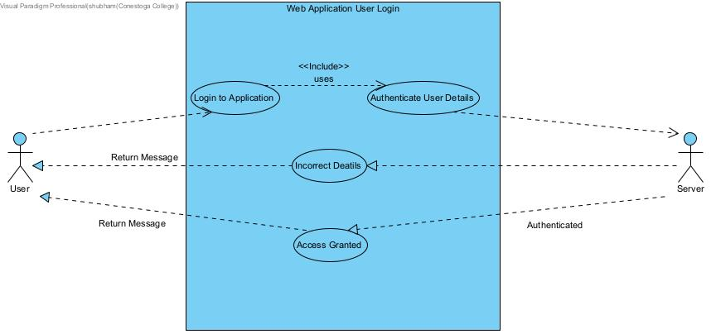

Figure 1: Use case diagram 1

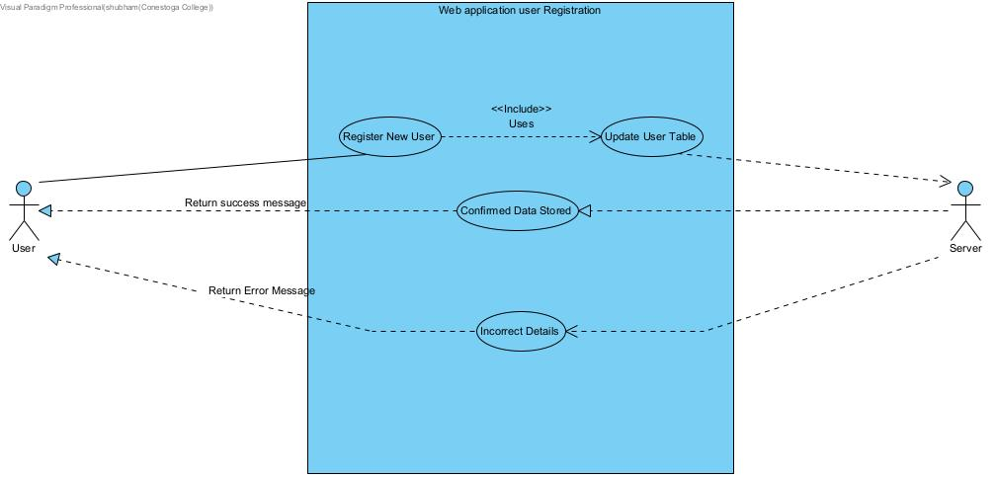

Figure 2: Use case diagram 2

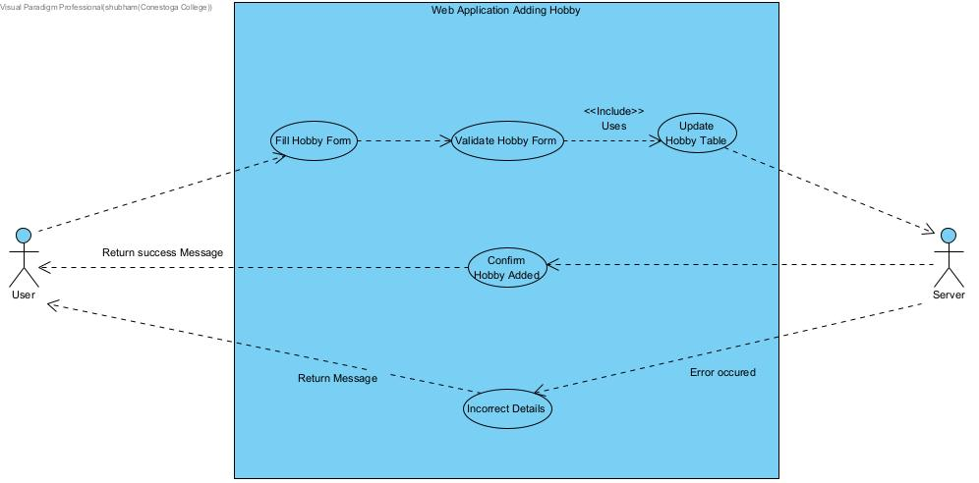

Figure 3: Use case diagram 3

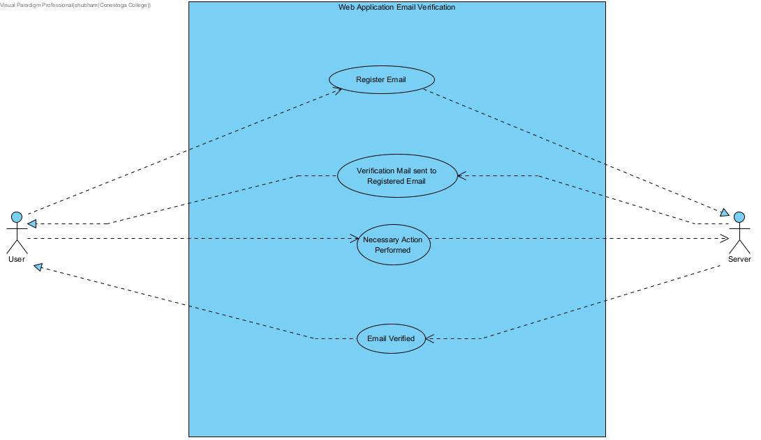

Figure 4: Use case diagram 4

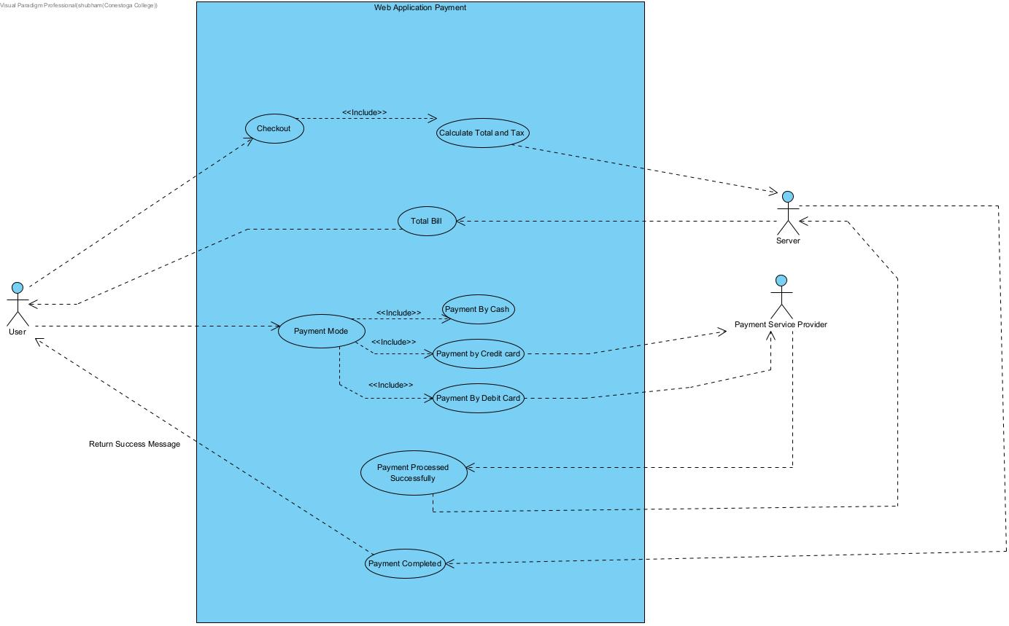

Figure 5: Use case diagram 5

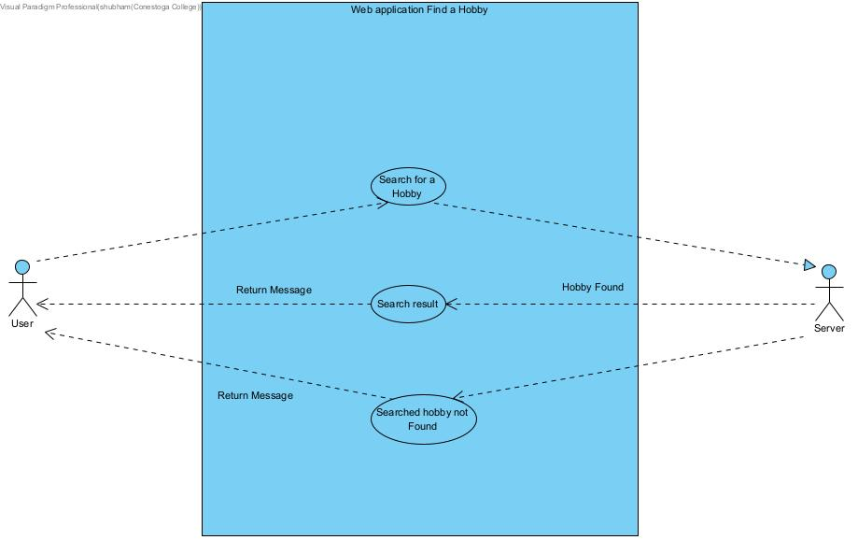

Figure 6: Use case diagram 6

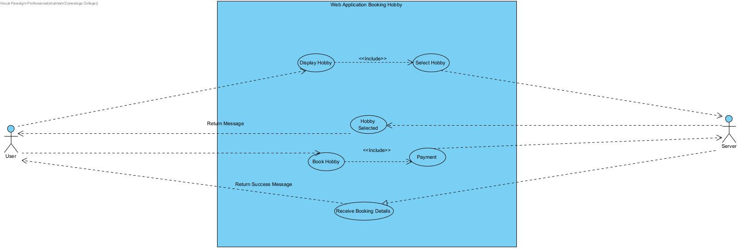

Figure 7: Use case diagram 7

*Created with the Personal Edition of HelpNDoc:* [*Easy CHM and documentation editor*](https://www.helpndoc.com)

**Class Diagram**

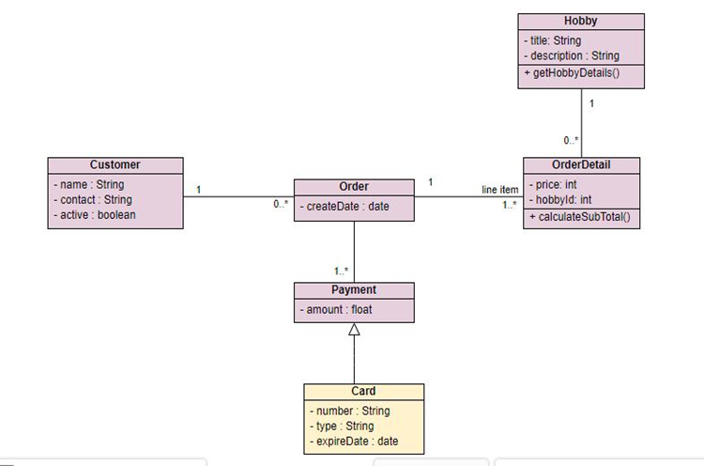

*Created with the Personal Edition of HelpNDoc:* [*Free CHM Help documentation generator*](https://www.helpndoc.com)

**System Sequence Diagram**

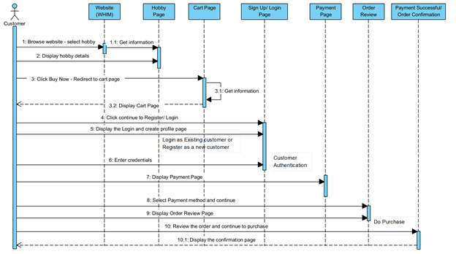

*Created with the Personal Edition of HelpNDoc:* [*iPhone web sites made easy*](https://www.helpndoc.com/feature-tour/iphone-website-generation)

**Design Phase**

*Created with the Personal Edition of HelpNDoc:* [*Free CHM Help documentation generator*](https://www.helpndoc.com)

**Class Diagram**

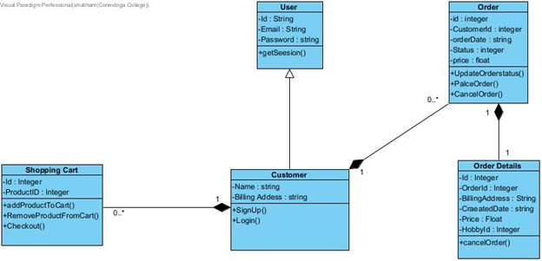

*Created with the Personal Edition of HelpNDoc:* [*Easily create PDF Help documents*](https://www.helpndoc.com/feature-tour)

**Data Dictionary**

Table Name: Users

|  |  |  |  |  |  |
| --- | --- | --- | --- | --- | --- |
| PK/FK | Field Name | Description | Caption | Type | Size |
| PK | User_id | Unique Id for each User | Nothing | Integer |  |
|  | User_Name | User Name | Nothing | String | 25 |
|  | Email | User Email | Nothing | String | 50 |
|  | Password | User Password | Nothing | String | 10 |
|  | Last_login | Last login accessed date and time | Nothing | DateTime |  |
|  | User_Created | User registered on date and time | Nothing | DateTime |  |

Table Name: Purchase

|  |  |  |  |  |  |
| --- | --- | --- | --- | --- | --- |
| PK/FK | Field Name | Description | Caption | Type | Size |
| PK | Purchase_id | Unique Id for purchase |  | Integer |  |
| FK | User_id | User Id which is used for purchase |  | Integer |  |
|  | Order_Date | Date on which the order placed |  | DateTime |  |
|  | Total_Cost | Total amount paid for the order |  | Float | 20 |
|  | Status | Status of the purchase |  | Boolean |  |

Table Name: Product

|  |  |  |  |  |  |
| --- | --- | --- | --- | --- | --- |
| PK/FK | Field Name | Description | Caption | Type | Size |
| PK | Product_id | Unique Id for product |  | Integer |  |
|  | Product_Name | Name of the product |  | String | 50 |
|  | Price | Price of the product |  | Float | 20 |
|  | Category | Product Category |  | String | 50 |
|  | Publisher | Who posted the product |  | String | 50 |

Table Name: Posts

|  |  |  |  |  |  |
| --- | --- | --- | --- | --- | --- |
| PK/FK | Field Name | Description | Caption | Type | Size |
| PK | Post_Id | Unique Id for Post |  | Integer |  |
| FK | User_Id | User Id of the user who posted the post |  | Integer |  |
|  | Product_Name | Name of the product |  | String | 50 |
|  | Post_Description | Description of the post |  | String | 20 |
|  | Post_Date | Date posted on |  | DateTime |  |

Table Name: Posts

|  |  |  |  |  |  |
| --- | --- | --- | --- | --- | --- |
| PK/FK | Field Name | Description | Caption | Type | Size |
| PK | Post_Id | Unique Id for Post |  | Integer |  |
| FK | User_Id | User Id of the user who posted the post |  | Integer |  |
|  | Product_Name | Name of the product |  | String | 50 |
|  | Post_Description | Description of the post |  | String | 20 |
|  | Post_Date | Date posted on |  | DateTime |  |

*Created with the Personal Edition of HelpNDoc:* [*Generate Kindle eBooks with ease*](https://www.helpndoc.com/feature-tour/create-ebooks-for-amazon-kindle)

**Entity Relationship Diagram**

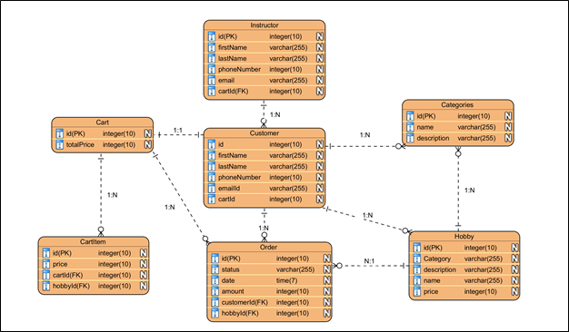

*Created with the Personal Edition of HelpNDoc:* [*Easy EBook and documentation generator*](https://www.helpndoc.com)

**Navigation Diagram**

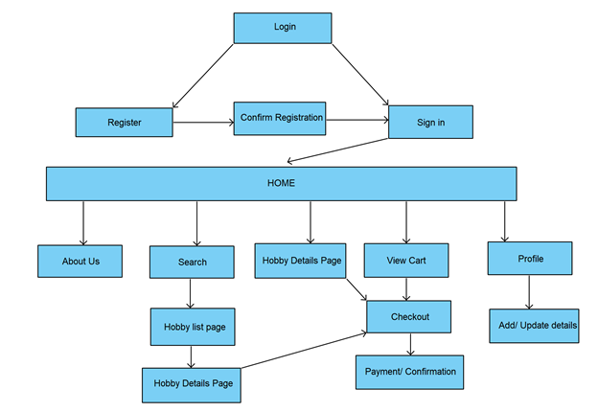

*Created with the Personal Edition of HelpNDoc:* [*Single source CHM, PDF, DOC and HTML Help creation*](https://www.helpndoc.com/help-authoring-tool)

**Sequence Diagram**

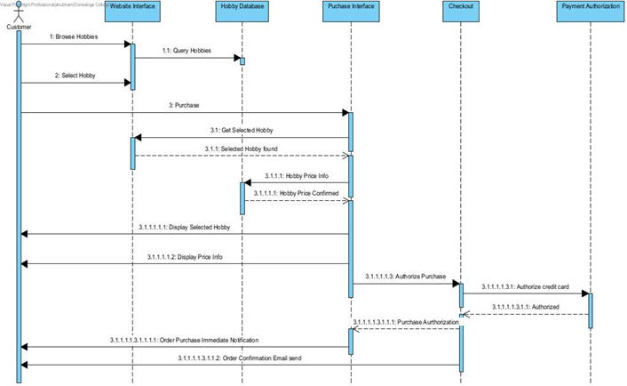

*Created with the Personal Edition of HelpNDoc:* [*Full-featured EBook editor*](https://www.helpndoc.com/create-epub-ebooks)

**Application Prototype**

**“Home Page”, User logged in as “Sample User”:**

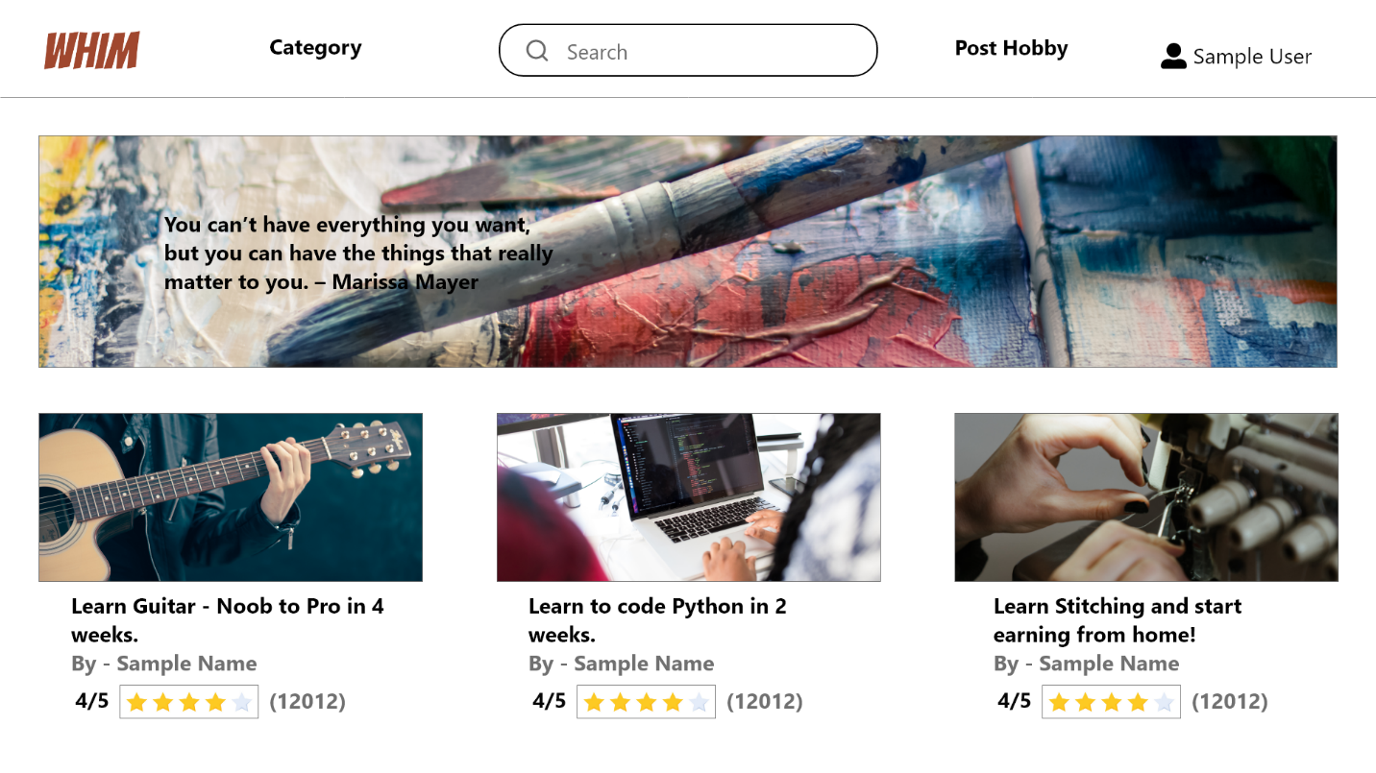

**“Home Page” when user is not logged in and comes as a guest:**

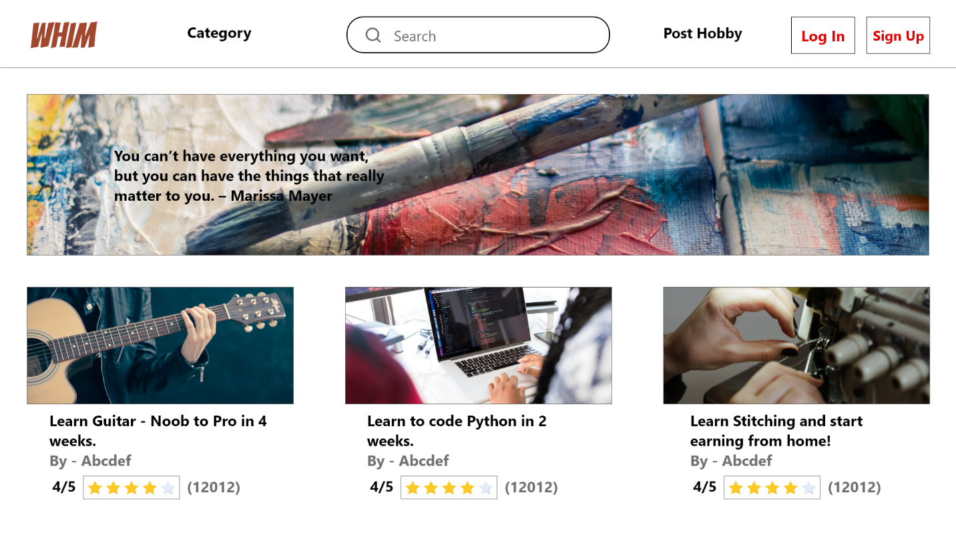

**User Login page:**

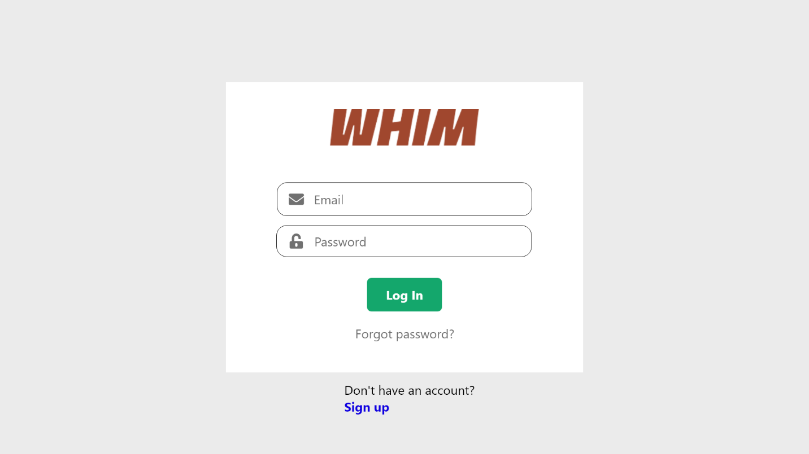

**Register User page:**

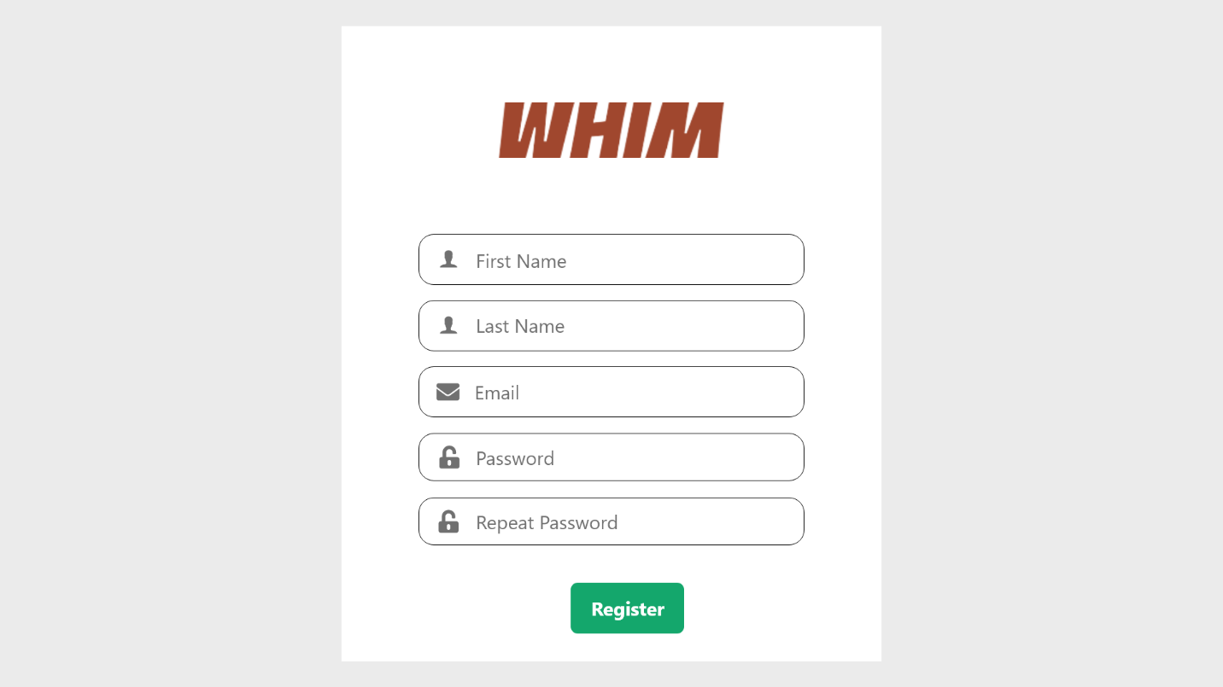

**User learning a course logged in as “Sample User” and already subscribed:**

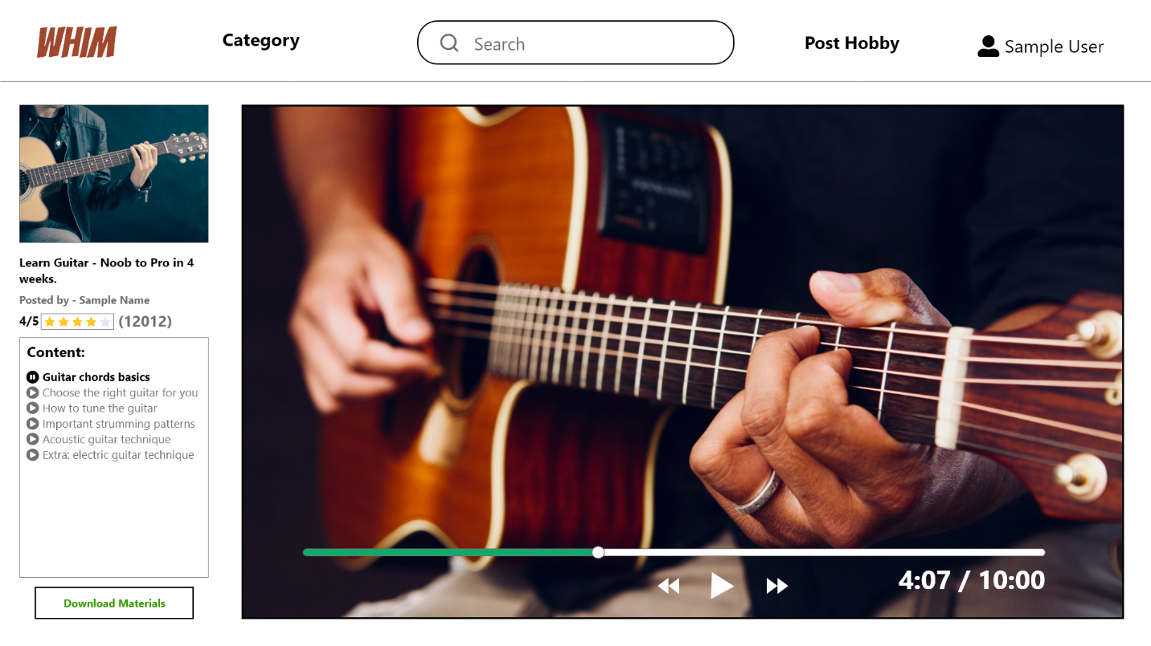

**Guest User checking a course, not logged in:**

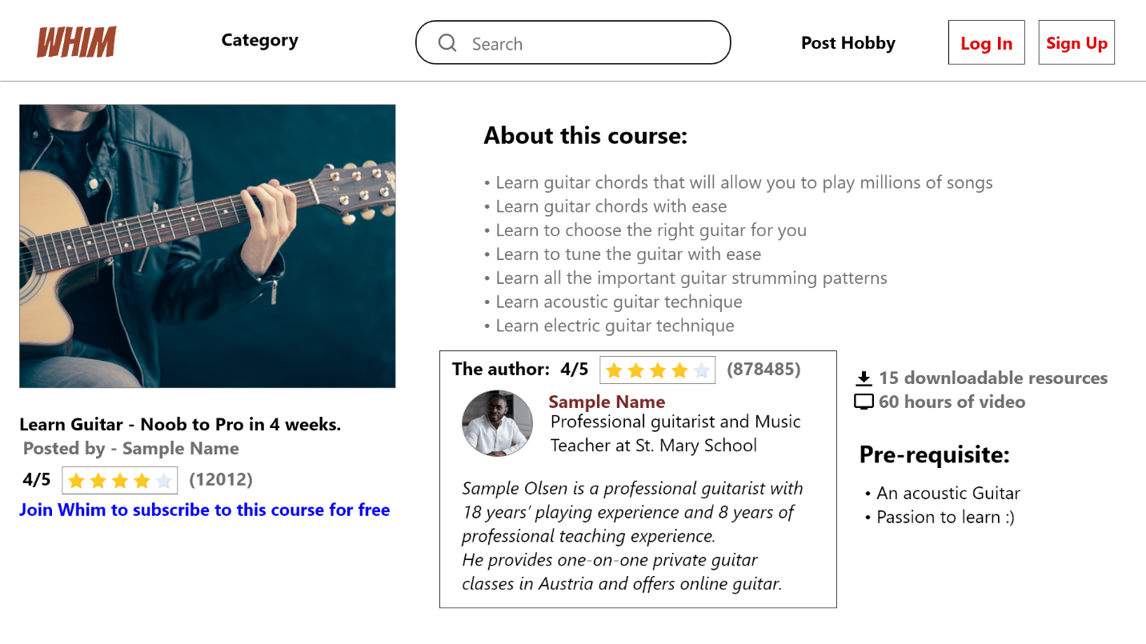

**User logged in as “Sample User” and subscribed, but has not started the course:**

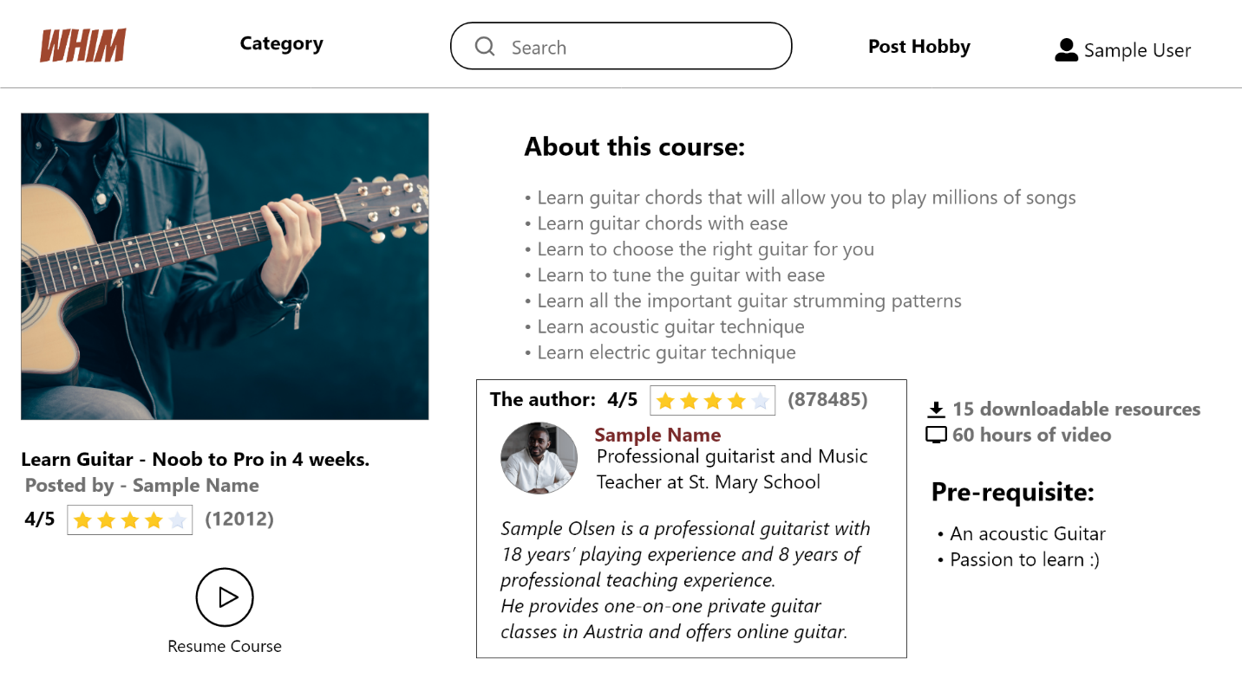

**User checking a course logged in as “Sample User” but not subscribed to it:**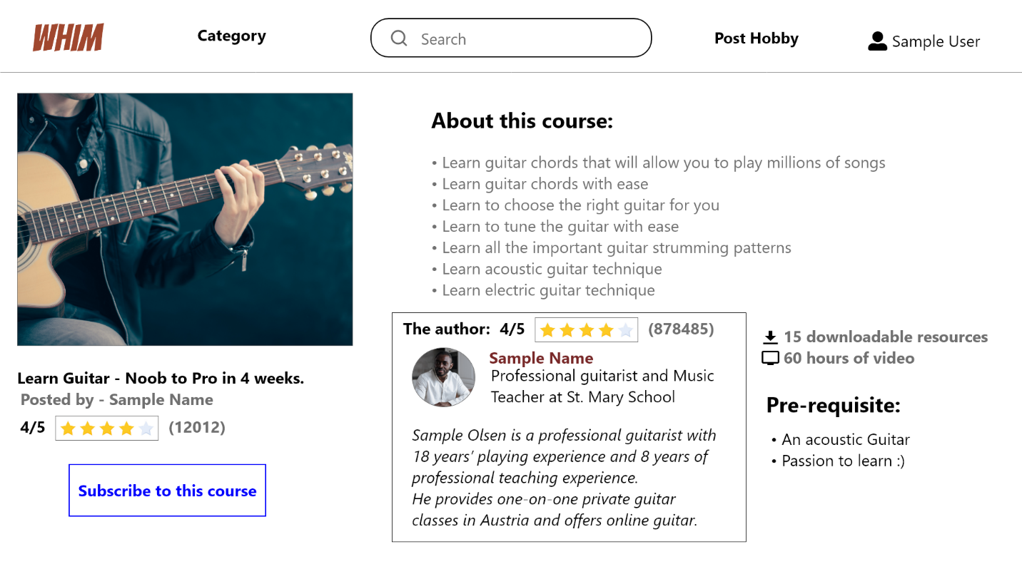

**Membership type:**

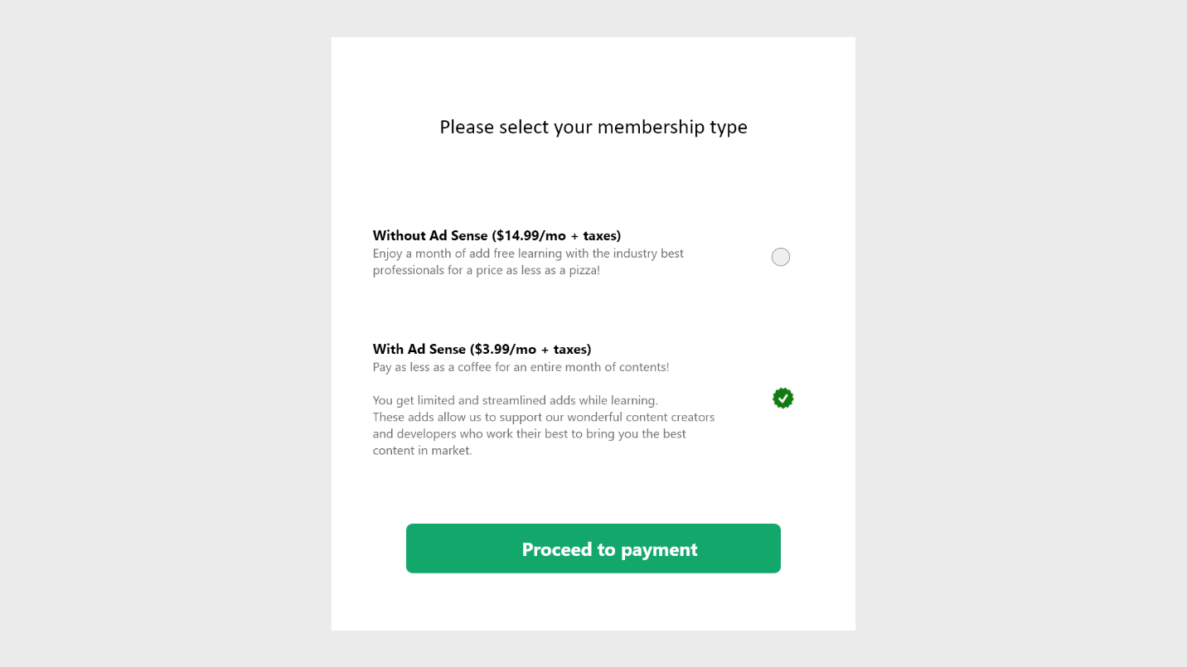

**Enter Payment Details Page:**

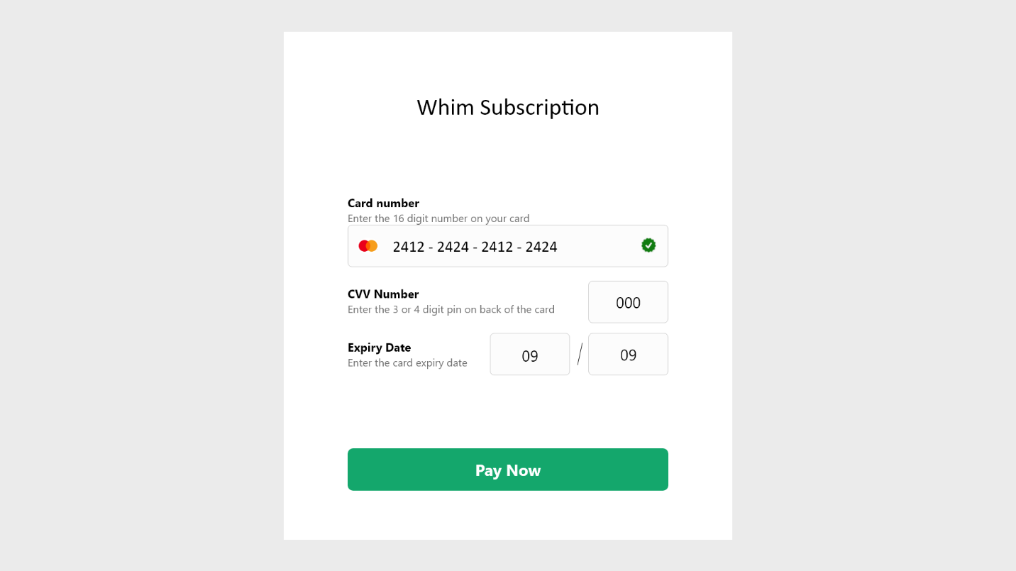

**Monthly subscription successful:**

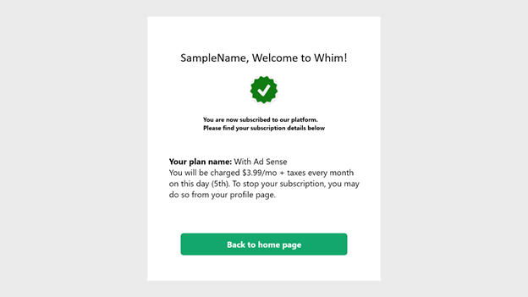

*Created with the Personal Edition of HelpNDoc:* [*Easily create Help documents*](https://www.helpndoc.com/feature-tour)

**Construction Phase**

*Created with the Personal Edition of HelpNDoc:* [*Single source CHM, PDF, DOC and HTML Help creation*](https://www.helpndoc.com/help-authoring-tool)

**Agile Iteration Summary**

1. Coordination Meetings

* Expected number of coordination team meetings: 4
* Actual number of coordination team meetings: 4
* Expected time per meeting: 1 hour
* Actual average time: 1.5 hours

1. Iteration Retrospective
2. What should the team stop doing?

Team is working as per the plan and everyone playing their part very well and completing their tasks on time. There are no conflicts or issues with the project plan or within the team that needs to be addressed. Everything is going well and there is nothing to be changed or stopped.

1. What should the team continue to do?

The team should continue to implement all the main features that are essentially important for the web application/Project.

1. What should the team start doing?

The team should start working on for the final day presentation video and all the required documentation for transition.

1. Additional Questions:

* Create use case description of User profile.
* Create state chart diagram for subscription life cycle and order life cycle.
* Implement UI designs, backend APIs and business logic for features:

1. User profile
2. Subscriptions
3. Manage hobby contents
4. Post hobby
5. Database integration
6. User account settings page

* Unit testing.
* Fix bugs.

1. Which work items listed in the agile Iteration plan were completed in this iteration?

* Completed features:

1. Payment/subscription page
2. Welcome page for the new user page
3. Course about page
4. Post new Hobby feature
5. My Account page
6. Application database integration

These features are completed as we progressed through this iteration plan. These features are essential for the project, and they mainly represent the web application in true sense. The more time was spent into complex features such as making the database integration dynamic instead of hard coded, Course content management, posting new hobbies/courses.

1. Is any rework required to the project plan going forward into the next iteration?

As per the latest testing and features there should not be any required for the project. Everything taken care of as per the plan and there is no rework needed for the added features in future.

*Created with the Personal Edition of HelpNDoc:* [*Free CHM Help documentation generator*](https://www.helpndoc.com)

**unit Test Plan and Results**

|  |  |  |  |
| --- | --- | --- | --- |
| Project name: | WHIM | | |
| Module (e.g., class) name: | Login/Registration | | |
| Designed by: | Shubham Singh | Design date: | 05th April, 2022 |
| Executed by: | Shubham Singh | Execution date: | 05th April, 2022 |

|  |  |  |  |
| --- | --- | --- | --- |
| Test  case # | Test | Expected Result | As Expected  (Y/N) |
| 1 | Login: Login validation | | |
|  | Go to Login page | Login Page displayed | Y |
|  | Enter Registered email address | Email address format validation | Y |
|  | Enter password | Entered password converted to asterisks | Y |
|  | Login credentials verification | Display Home Page if Email and password match | Y |
|  | Login credentials verification | Display error message if Email and password mismatch | Y |

|  |  |  |  |
| --- | --- | --- | --- |
| Test  case # | Test | Expected Result | As Expected  (Y/N) |
| 2 | Registration: Registration form validation | | |
|  | Go to Registration page | Registration Page displayed | Y |
|  | Enter Form Information | Information Validated | Y |
|  | Email format validation | Validates correct email format | Y |
|  | Password format validation | Validates password character combination requirement | Y |
|  | Unique email id validation | Checks database for registered email ids | Y |
|  | Click Registration | Success message displayed if entered information validates | Y |

|  |  |  |  |
| --- | --- | --- | --- |
| Test  case # | Test | Expected Result | As Expected  (Y/N) |
| 3 | Post Hobby: hobby posting validation | | |
|  | Go to post hobby page | Post hobby Page displayed | Y |
|  | Enter hobby information | Hobby information validated | Y |
|  | Click Post | Hobby will be added to application home page | Y |

|  |  |  |  |
| --- | --- | --- | --- |
| Test  case # | Test | Expected Result | As Expected  (Y/N) |
| 4 | Delete Hobby: Deleting hobby from application | | |
|  | Go to Delete hobby page | Delete hobby Page displayed | Y |
|  | Select hobby to delete | Selected hobbies will be highlighted | Y |
|  | Click Delete | Delete hobby confirmation warning displayed | Y |
|  | Click Confirm delete | Hobby will be removed from the home page | Y |

|  |  |  |  |
| --- | --- | --- | --- |
| Test  case # | Test | Expected Result | As Expected  (Y/N) |
| 5 | Subscribe User: Subscription validation | | |
|  | Go to subscribe page | Subscribe Page displayed | Y |
|  | Click Subscribe | Subscription page displayed | Y |
|  | Click Checkout | Payment page displayed | Y |
|  | Confirm Total amount | Total amount will be displayed for payment | Y |
|  | Enter credit card details | Credit details will be validated for transaction | Y |
|  | Payment confirmation | Success message displayed | Y |

|  |  |  |  |
| --- | --- | --- | --- |
| Test  case # | Test | Expected Result | As Expected  (Y/N) |
| 6 | Unsubscribe User: Unsubscribe user validation | | |
|  | Go to subscription page | Subscription Page displayed | Y |
|  | Click Unsubscribe | Unsubscribe confirmation page displayed | Y |
|  | Click Confirm | Subscribe page displayed | Y |

|  |  |  |  |
| --- | --- | --- | --- |
| Test  case # | Test | Expected Result | As Expected  (Y/N) |
| 7 | Edit User account: change User Account settings | | |
|  | Go to My Account page | My Account Page displayed | Y |
|  | Click profile | Profile page displayed | Y |
|  | Edit User Information | Information Edited and validated | Y |
|  | Click Save | Confirmation popup displayed | Y |
|  | Click Confirmation | My Account page displayed | Y |

|  |  |  |  |
| --- | --- | --- | --- |
| Test  case # | Test | Expected Result | As Expected  (Y/N) |
| 8 | Hobby Detail: Hobby contents and information | | |
|  | Click on specific hobby title or card | Selected hobby Page displayed | Y |
|  | Hobby title | Hobby title matches with the selected hobby | Y |
|  | Rate Hobby | Select rating starts out of 5 stars | Y |
|  | Stars selected | Same selected stars will be displayed | Y |

|  |  |  |  |
| --- | --- | --- | --- |
| Test  case # | Test | Expected Result | As Expected  (Y/N) |
| 9 | Payment: Paying for Subscription | | |
|  | Go to Payment page | Payment Page displayed | Y |
|  | Enter Credit Details | Payment Form filled with credit card details | Y |
|  | Payment Form Validation | Credit card information will be validated with the correct formats of the payment form | Y |
|  | Click Pay | Payment Confirmation popup displayed with total amount | Y |
|  | Click Confirmation | Home page displayed | Y |

**Integration Testing:**

|  |  |  |  |
| --- | --- | --- | --- |
| Project name: | WHIM | | |
| Module (e.g., class) name: | Login/Registration | | |
| Designed by: | Shubham Singh | Design date: | 05th April, 2022 |
| Executed by: | Shubham Singh | Execution date: | 05th April, 2022 |

|  |  |  |  |  |  |
| --- | --- | --- | --- | --- | --- |
| Test  case # | Title | Test data (and steps) | Expected Result | Actual Result | Success  (Y/N) |
| 1 | Login validation  (Enter correct credentials) | 1. Login validation | User should be allow to access their account and able to use all the available features of the application and should be able to manage their account profile | User can login to the application and successfully able to access the list of all the available parking spots at nearby location | Y |
| 2 | Login validation  (Enter incorrect credentials) | 1. Login validation | Application should display error message to user for entering incorrect details | Application displayed error message to user | Y |

|  |  |  |  |
| --- | --- | --- | --- |
| Project name: | WHIM | | |
| Module (e.g., class) name: | Subscription Payment | | |
| Designed by: | Swagat Samal | Design date: | 05th April, 2022 |
| Executed by: | Swagat Samal | Execution date: | 05th April, 2022 |

|  |  |  |  |  |  |
| --- | --- | --- | --- | --- | --- |
| Test  case # | Title | Test data (and steps) | Expected Result | Actual Result | Success  (Y/N) |
| 1 | Credit Card Details  (Enter Correct Details) | 1. Payment Validation | User should be able to see a payment confirmation message and should receive a payment confirmation email. | User should be able to access the subscribed course. | Y |
| 2 | Credit Card Details  (Enter Wrong Details) | 1. Payment Validation | User should be able to see Transaction failed message and should ask to perform the transaction again. | User should be able to perform the transaction again. | Y |

|  |  |  |  |
| --- | --- | --- | --- |
| Project name: | WHIM | | |
| Module (e.g., class) name: | Hobby/Course | | |
| Designed by: | Puneet Chopra | Design date: | 05th April, 2022 |
| Executed by: | Puneet Chopra | Execution date: | 05th April, 2022 |

|  |  |  |  |  |  |
| --- | --- | --- | --- | --- | --- |
| Test  case # | Title | Test data (and steps) | Expected Result | Actual Result | Success  (Y/N) |
| 1 | Posting a new course  (Adding new Course) | 1. Course Added to Database | New course data should be added to database  Whenever a new course is added to the web application.  Should be visible to users to subscribe. | User is able to login to the application and successfully able to access the list of all the available parking spots at nearby location | Y |
| 2 | Updating the Course (Updating the course content) | 1. Course Updated to Database | All the modified data should be updated to specific course without creating a new entry for the existing course. | Application should be able to reflect all the changes instantly. | Y |

*Created with the Personal Edition of HelpNDoc:* [*iPhone web sites made easy*](https://www.helpndoc.com/feature-tour/iphone-website-generation)

**Transition Phase**

*Created with the Personal Edition of HelpNDoc:* [*Full-featured Help generator*](https://www.helpndoc.com/feature-tour)

**Agile Backlog template**

|  |  |  |  |  |
| --- | --- | --- | --- | --- |
| **Conestoga College** | |  |  |  |
| **Team:** | Swagat Samal, Shubham Singh, Puneet Chopra |  |  |  |
|  |  |  |  |  |
| **Agile Product Feature List - Backlog Template** | |  |  |  |
|  |  |  |  |  |
| **#** | **Description** | **PD est.** | **By** | Note: PD = Person day = 4 hours; start feature # from 101 (reserve 1-100 for other requirements) |
|  |  |  |  |  |
|  | **High Priority** |  |  | Note: Only high priority items are prioritized, assigned to iteration, and estimated |
|  | Iteration 1 |  |  |  |
| 101 | Use case diagram | 1 | SS |  |
| 102 | Project setup | 2 | SS |  |
| 103 | Analysis Level Class Diagram | 1 | PC |  |
| 104 | System Sequence Diagram | 1 | PC |  |
| 105 | State Chart Diagram | 1 | SS |  |
| 106 | Design login page | 2 | PC |  |
| 107 | Design Registration page | 2 | SS |  |
| 108 | Email Validation for registration | 3 | SS |  |
| 109 | Design Database | 4 | SS |  |
|  | Iteration 2 |  |  |  |
| 110 | Class Diagram | 1 | SS |  |
| 111 | Data Dictionary | 1 | SS |  |
| 112 | Entity Relation Diagram | 1 | PC |  |
| 113 | Navigation Diagram | 1 | PC |  |
| 114 | Sequence Diagram | 1 | SS |  |
| 115 | Application Prototype | 5 | SS |  |
|  | Iteration 3 |  |  |  |
| 116 | User Profile Page | 3 | SS |  |
| 117 | Subsciption Page | 7 | SS |  |
| 118 | Manage Post Content | 4 | PC |  |
| 119 | Post Hobby | 3 | SS |  |
| 120 | Database integeration | 6 | PC |  |
| 121 | User Account Settings Page | 7 | SS |  |
|  | **Medium Priority** |  | SS | Note: Medium and Low are prioritized but not yet assigned to iteration, nor estimated |
| 122 | Unit Testing of application | 2 | SS |  |
| 123 | Bug Fixes | 3 | SS |  |
|  |  |  |  |  |
|  |  |  |  |  |
|  |  |  |  |  |
|  | **Low Priority** |  |  |  |
| 124 | Web Application Styling Review | 3 | PC |  |
| 125 | Populating Application with meaningful related data | 1 | SS |  |

*Created with the Personal Edition of HelpNDoc:* [*Easily create iPhone documentation*](https://www.helpndoc.com/feature-tour/iphone-website-generation)

**Agile Release Summary**

|  |  |  |  |  |  |  |  |  |
| --- | --- | --- | --- | --- | --- | --- | --- | --- |
| **Conestoga College** | |  |  |  |  |  |  |  |
|  |  |  |  |  |  |  |  |  |
| **Team:** | Swagat Samal, Shubham Singh, Puneet Chopra |  |  |  |  |  |  |  |
|  |  |  |  |  |  |  |  |  |
| **Release Plan Summary** | |  |  |  |  |  |  |  |
|  |  |  |  |  |  |  |  |  |
|  |  | **Inception** | **Iteration #1** | **Iteration #2** | **Iteration #3** | **Transition** |  |  |
|  |  | Due: Jan-23 | Due: Feb-13 | Due: Mar-13 | Due: Apr-3 | Due: Apr-24 |  |  |
| **#** | **Feature / Requirement** |  |  |  |  |  |  |  |
| 1 | Project Vision statement | 4 |  |  |  |  |  |  |
|  | Market Research | 5 |  |  |  |  |  |  |
|  | Application Template | 5 |  |  |  |  |  |  |
|  |  |  |  |  |  |  |  |  |
| 110 | Project Setup |  | 3 |  |  |  |  |  |
| 101 | Database Design |  | 4 |  |  |  |  |  |
|  | Login Page Design |  | 7 |  |  |  |  |  |
|  | Registration Page Design |  | 6 |  |  |  |  |  |
|  | Application Flow |  | 5 |  |  |  |  |  |
|  | Email Validation |  | 3 |  |  |  |  |  |
|  |  |  |  |  |  |  |  |  |
| 107 | Application Prototype |  |  | 8 |  |  |  |  |
| 109 | UI implemented for Login page |  |  | 6 |  |  |  |  |
|  | UI implemented for Registration page |  |  | 6 |  |  |  |  |
|  | UI implemented for Home Page |  |  | 7 |  |  |  |  |
|  |  |  |  |  |  |  |  |  |
|  | Application Design template |  |  |  | 6 |  |  |  |
|  | Meaningfull Datat populated to application |  |  |  | 5 |  |  |  |
|  | Bugs fixes |  |  |  | 5 |  |  |  |
|  | Application UI Completed |  |  |  | 9 |  |  |  |
|  | Application Payment/Subcription plan decided |  |  |  | 8 |  |  |  |
|  |  |  |  |  |  |  |  |  |
|  | Implemented User Profile Page |  |  |  |  | 6 |  |  |
|  | Implemented Subscription page |  |  |  |  | 8 |  |  |
|  | Implemented Post hobby feature |  |  |  |  | 7 |  |  |
|  | Implemented Database integeration |  |  |  |  | 9 |  |  |
|  | Implemented My Account Feature |  |  |  |  | 9 |  |  |
|  | Implemented Author Profile page |  |  |  |  | 8 |  |  |
|  |  |  |  |  |  |  |  |  |
|  | Work Effort in Person Days (PD) | 14 | 28 | 27 | 33 | 47 | **149** | Target: 135 to 150 PD for team of 3 |
|  |  |  |  |  |  |  |  | Given: 1 PD = 4 hours |
|  |  |  |  |  |  |  |  | Estimate: 3 PD per week = 45 PD per member; 135 PD for team of 3 |

*Created with the Personal Edition of HelpNDoc:* [*Produce online help for Qt applications*](https://www.helpndoc.com/feature-tour/create-help-files-for-the-qt-help-framework)

**Project ID Sheet with Deployment Guide**

# Team Name: Code Cartel



# Team Members:

*Swagat Samal*

*Shubham Singh*

*Puneet Chopra*

# About {Project Name}

The aim of this app is to bring like-minded people together and help people share or get help on their hobbies. We will enable two types of users: users who is willing to help and user who is looking for help with their hobbies.

Ex: I wish to learn guitar, I can look for people willing to teach me on the website.

# Quick Start

*Explain how to get the application up and running as quickly as possible in the simplest configuration*

# Deployment Instructions

## How to Create the Database

Step 1:

*Install Mongoose on your system.*

*You can download this from the below link:*

[*https://www.mongodb.com/try/download/community*](https://www.mongodb.com/try/download/community)

*Step 2:*

*Start backend server: npm start*

*Note: now the backend server will start, and database and tables will be automatically created.*

## How to Install and Configure the Web Site

*Step 1: Start the backend server with the command: npm start*

*Step 2: start the front-end server with the command: npm start*

*Once the server starts it will give you a message about the URL of the website (or go to* [*http://localhost:3000*](http://localhost:3000)*). The web application will start on the browser.*

# Waiver

The undersigned permit Conestoga College Information Technology faculty to use the finished application and other deliverables for classroom demonstrations and the marketing of Conestoga College Information Technology programs. Conestoga College Information Technology faculty agree to use the source code only for marking purposes, and not to disclose or distribute the source code to any third party.

Signature : Swagat Samal Date : 16 April 2022

Signature : Shubham Singh Date : 16 April 2022

Signature : Puneet Chopra Date : 16 April 2022

*Created with the Personal Edition of HelpNDoc:* [*Easy to use tool to create HTML Help files and Help web sites*](https://www.helpndoc.com/help-authoring-tool)

**User and System Test Plan and Results**

|  |  |  |  |
| --- | --- | --- | --- |
| Project name: | WHIM | | |
| Module (e.g., class) name: | Login/Registration | | |
| Designed by: | Shubham Singh | Design date: | 16th April, 2022 |
| Executed by: | Shubham Singh | Execution date: | 16th April, 2022 |

|  |  |  |  |
| --- | --- | --- | --- |
| Test  case # | Test | Expected Result | As Expected  (Y/N) |
| 1 | Login: Login validation | | |
|  | Go to Login page | Login Page displayed | Y |
|  | Enter Registered email address | Email address format validation | Y |
|  | Enter password | Entered password converted to asterisks | Y |
|  | Login credentials verification | Display Home Page if Email and password match | Y |
|  | Login credentials verification | Display error message if Email and password mismatch | Y |

|  |  |  |  |
| --- | --- | --- | --- |
| Test  case # | Test | Expected Result | As Expected  (Y/N) |
| 2 | Registration: Registration form validation | | |
|  | Go to Registration page | Registration Page displayed | Y |
|  | Enter Form Information | Information Validated | Y |
|  | Email format validation | Validates correct email format | Y |
|  | Password format validation | Validates password character combination requirement | Y |
|  | Unique email id validation | Checks database for registered email ids | Y |
|  | Click Registration | Success message displayed if entered information validates | Y |

|  |  |  |  |
| --- | --- | --- | --- |
| Test  case # | Test | Expected Result | As Expected  (Y/N) |
| 3 | Post Hobby: hobby posting validation | | |
|  | Go to post hobby page | Post hobby Page displayed | Y |
|  | Enter hobby information | Hobby information validated | Y |
|  | Click Post | Hobby will be added to application home page | Y |

|  |  |  |  |
| --- | --- | --- | --- |
| Test  case # | Test | Expected Result | As Expected  (Y/N) |
| 4 | Delete Hobby: Deleting hobby from application | | |
|  | Go to Delete hobby page | Delete hobby Page displayed | Y |
|  | Select hobby to delete | Selected hobbies will be highlighted | Y |
|  | Click Delete | Delete hobby confirmation warning displayed | Y |
|  | Click Confirm delete | Hobby will be removed from the home page | Y |

|  |  |  |  |
| --- | --- | --- | --- |
| Test  case # | Test | Expected Result | As Expected  (Y/N) |
| 5 | Subscribe User: Subscription validation | | |
|  | Go to subscribe page | Subscribe Page displayed | Y |
|  | Click Subscribe | Subscription page displayed | Y |
|  | Click Checkout | Payment page displayed | Y |
|  | Confirm Total amount | Total amount will be displayed for payment | Y |
|  | Enter credit card details | Credit details will be validated for transaction | Y |
|  | Payment confirmation | Success message displayed | Y |

|  |  |  |  |
| --- | --- | --- | --- |
| Test  case # | Test | Expected Result | As Expected  (Y/N) |
| 6 | Unsubscribe User: Unsubscribe user validation | | |
|  | Go to subscription page | Subscription Page displayed | Y |
|  | Click Unsubscribe | Unsubscribe confirmation page displayed | Y |
|  | Click Confirm | Subscribe page displayed | Y |

|  |  |  |  |
| --- | --- | --- | --- |
| Test  case # | Test | Expected Result | As Expected  (Y/N) |
| 7 | Edit User account: change User Account settings | | |
|  | Go to My Account page | My Account Page displayed | Y |
|  | Click profile | Profile page displayed | Y |
|  | Edit User Information | Information Edited and validated | Y |
|  | Click Save | Confirmation popup displayed | Y |
|  | Click Confirmation | My Account page displayed | Y |

|  |  |  |  |
| --- | --- | --- | --- |
| Test  case # | Test | Expected Result | As Expected  (Y/N) |
| 8 | Hobby Detail: Hobby contents and information | | |
|  | Click on specific hobby title or card | Selected hobby Page displayed | Y |
|  | Hobby title | Hobby title matches with the selected hobby | Y |
|  | Rate Hobby | Select rating starts out of 5 stars | Y |
|  | Stars selected | Same selected stars will be displayed | Y |

|  |  |  |  |
| --- | --- | --- | --- |
| Test  case # | Test | Expected Result | As Expected  (Y/N) |
| 9 | Payment: Paying for Subscription | | |
|  | Go to Payment page | Payment Page displayed | Y |
|  | Enter Credit Details | Payment Form filled with credit card details | Y |
|  | Payment Form Validation | Credit card information will be validated with the correct formats of the payment form | Y |
|  | Click Pay | Payment Confirmation popup displayed with total amount | Y |
|  | Click Confirmation | Home page displayed | Y |

**Integration Testing:**

|  |  |  |  |
| --- | --- | --- | --- |
| Project name: | WHIM | | |
| Module (e.g., class) name: | Login/Registration | | |
| Designed by: | Shubham Singh | Design date: | 16th April, 2022 |
| Executed by: | Shubham Singh | Execution date: | 16th April, 2022 |

|  |  |  |  |  |  |
| --- | --- | --- | --- | --- | --- |
| Test  case # | Title | Test data (and steps) | Expected Result | Actual Result | Success  (Y/N) |
| 1 | Login validation  (Enter correct credentials) | 1. Login validation | User should be allow to access their account and able to use all the available features of the application and should be able to manage their account profile | User can login to the application and successfully able to access the list of all the available parking spots at nearby location | Y |
| 2 | Login validation  (Enter incorrect credentials) | 1. Login validation | Application should display error message to user for entering incorrect details | Application displayed error message to user | Y |

|  |  |  |  |
| --- | --- | --- | --- |
| Project name: | WHIM | | |
| Module (e.g., class) name: | Subscription Payment | | |
| Designed by: | Swagat Samal | Design date: | 16th April, 2022 |
| Executed by: | Swagat Samal | Execution date: | 16th April, 2022 |

|  |  |  |  |  |  |
| --- | --- | --- | --- | --- | --- |
| Test  case # | Title | Test data (and steps) | Expected Result | Actual Result | Success  (Y/N) |
| 1 | Credit Card Details  (Enter Correct Details) | 1. Payment Validation | User should be able to see a payment confirmation message and should receive a payment confirmation email. | User should be able to access the subscribed course. | Y |
| 2 | Credit Card Details  (Enter Wrong Details) | 1. Payment Validation | User should be able to see Transaction failed message and should ask to perform the transaction again. | User should be able to perform the transaction again. | Y |

|  |  |  |  |
| --- | --- | --- | --- |
| Project name: | WHIM | | |
| Module (e.g., class) name: | Hobby/Course | | |
| Designed by: | Puneet Chopra | Design date: | 16th April, 2022 |
| Executed by: | Puneet Chopra | Execution date: | 16th April, 2022 |

|  |  |  |  |  |  |
| --- | --- | --- | --- | --- | --- |
| Test  case # | Title | Test data (and steps) | Expected Result | Actual Result | Success  (Y/N) |
| 1 | Posting a new course  (Adding new Course) | 1. Course Added to Database | New course data should be added to database  Whenever a new course is added to the web application.  Should be visible to users to subscribe. | User is able to login to the application and successfully able to access the list of all the available parking spots at nearby location | Y |
| 2 | Updating the Course (Updating the course content) | 1. Course Updated to Database | All the modified data should be updated to specific course without creating a new entry for the existing course. | Application should be able to reflect all the changes instantly. | Y |

*Created with the Personal Edition of HelpNDoc:* [*Free help authoring environment*](https://www.helpndoc.com/help-authoring-tool)

**Help And Support Tutorials**

**1.Introduction**

**Welcome**

The aim of this app is to bring like-minded people together and help people share or get help on their hobbies. We will enable two types of users: users who is willing to help and user who is looking for help with their hobbies.

Ex: I wish to learn guitar, I can look for people willing to teach me on the website.

**2.Getting Started**

**a.System Requirements**

**Technologies:**

ReactJS,

MongoDB,

GitHub for version control or code management,

JavaScript,

HTML,

SCSS.

**Tools used:**

VS Code,

Mongoose,

Google Chrome

**b.Getting help (contact info of the developers or customer service)**

1. Swagat Samal
2. Software Developer

Email: Ssamal@Conestogac.on.ca

1. Shubham Singh
2. Software Developer

Email: SSingh5808@conestogac.on.ca

1. Puneet Chopra
2. Software Developer

Email: Pchopra0250@conestogac.on.ca

**3.Features**

**a.Navigation**



**b.Registering an Account**

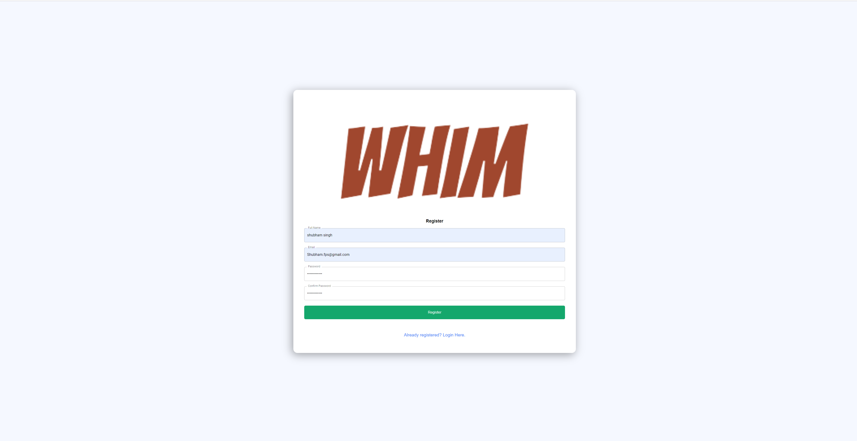

For registering a new user, form needs to be filled with the correct and validated input for successful registration.

**i.How to Log in**

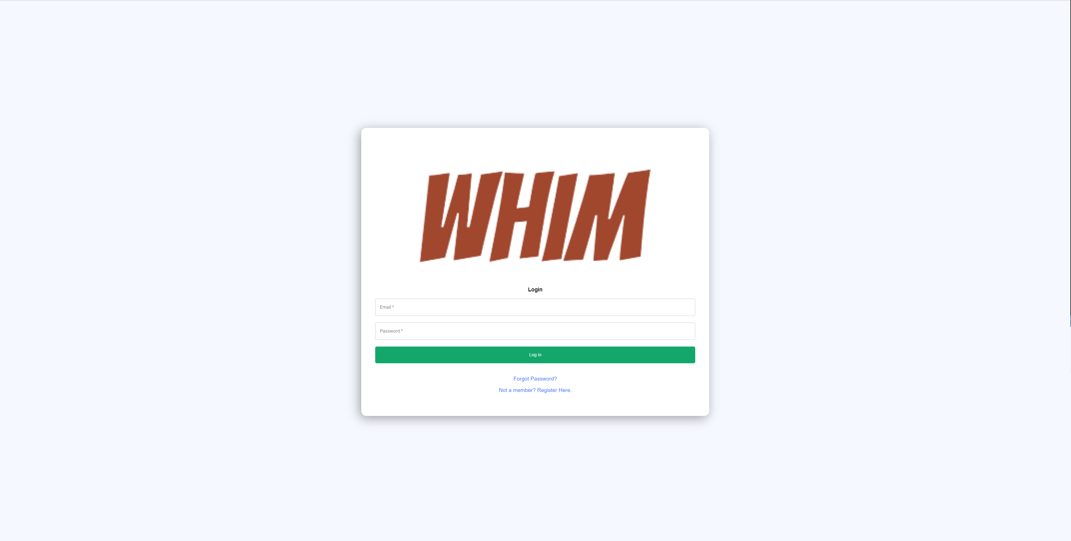

For login, user have to input registered credential.

**ii.Forgotten Password**

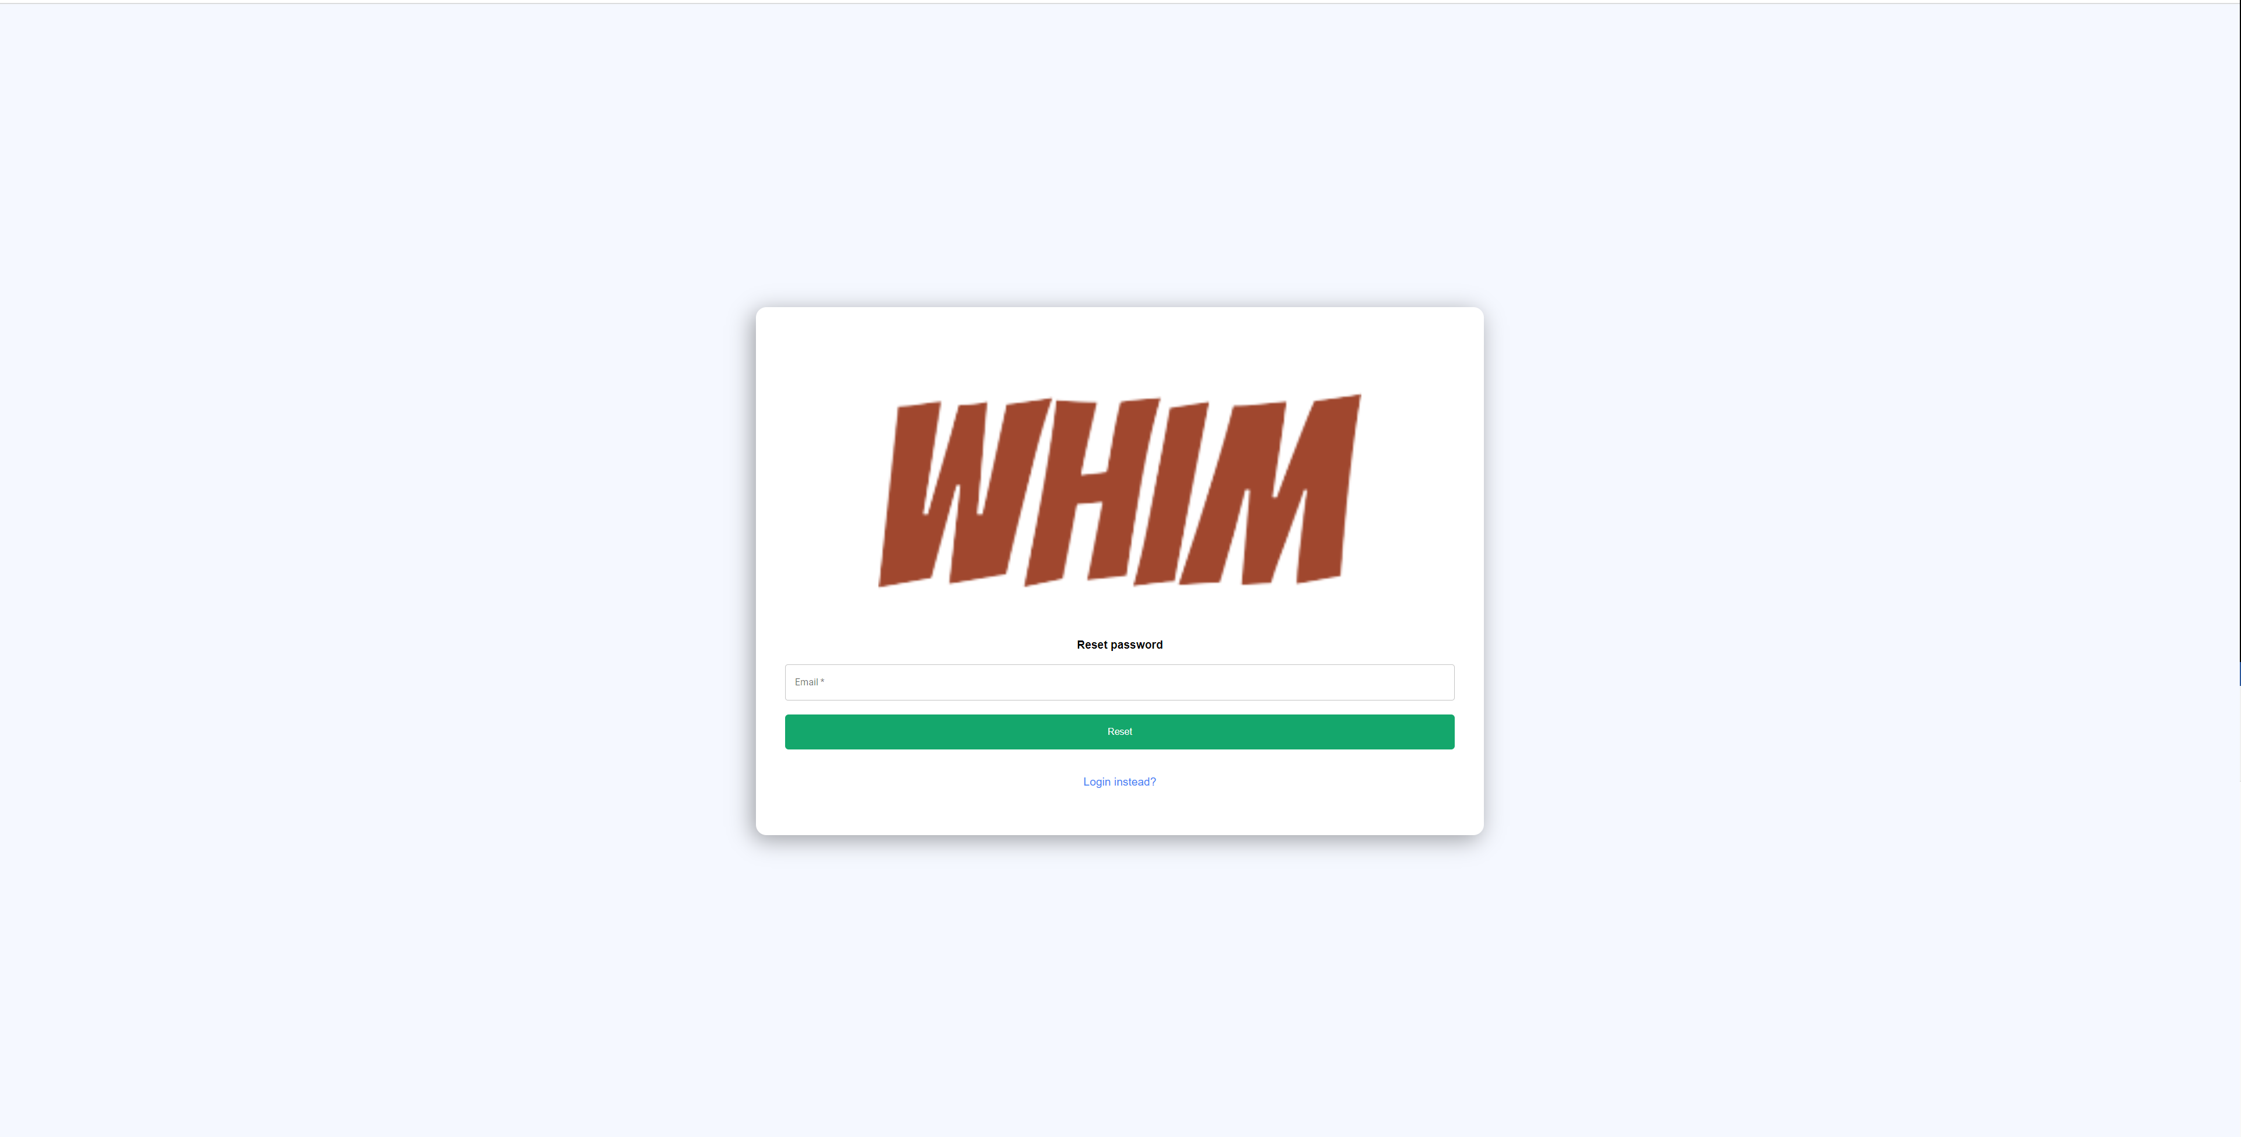

If a User forgets his/her password, user can reset their password by entering the registered email for which they want reset the password.

**iii.Change Password**

A reset link will be sent to registered email address:

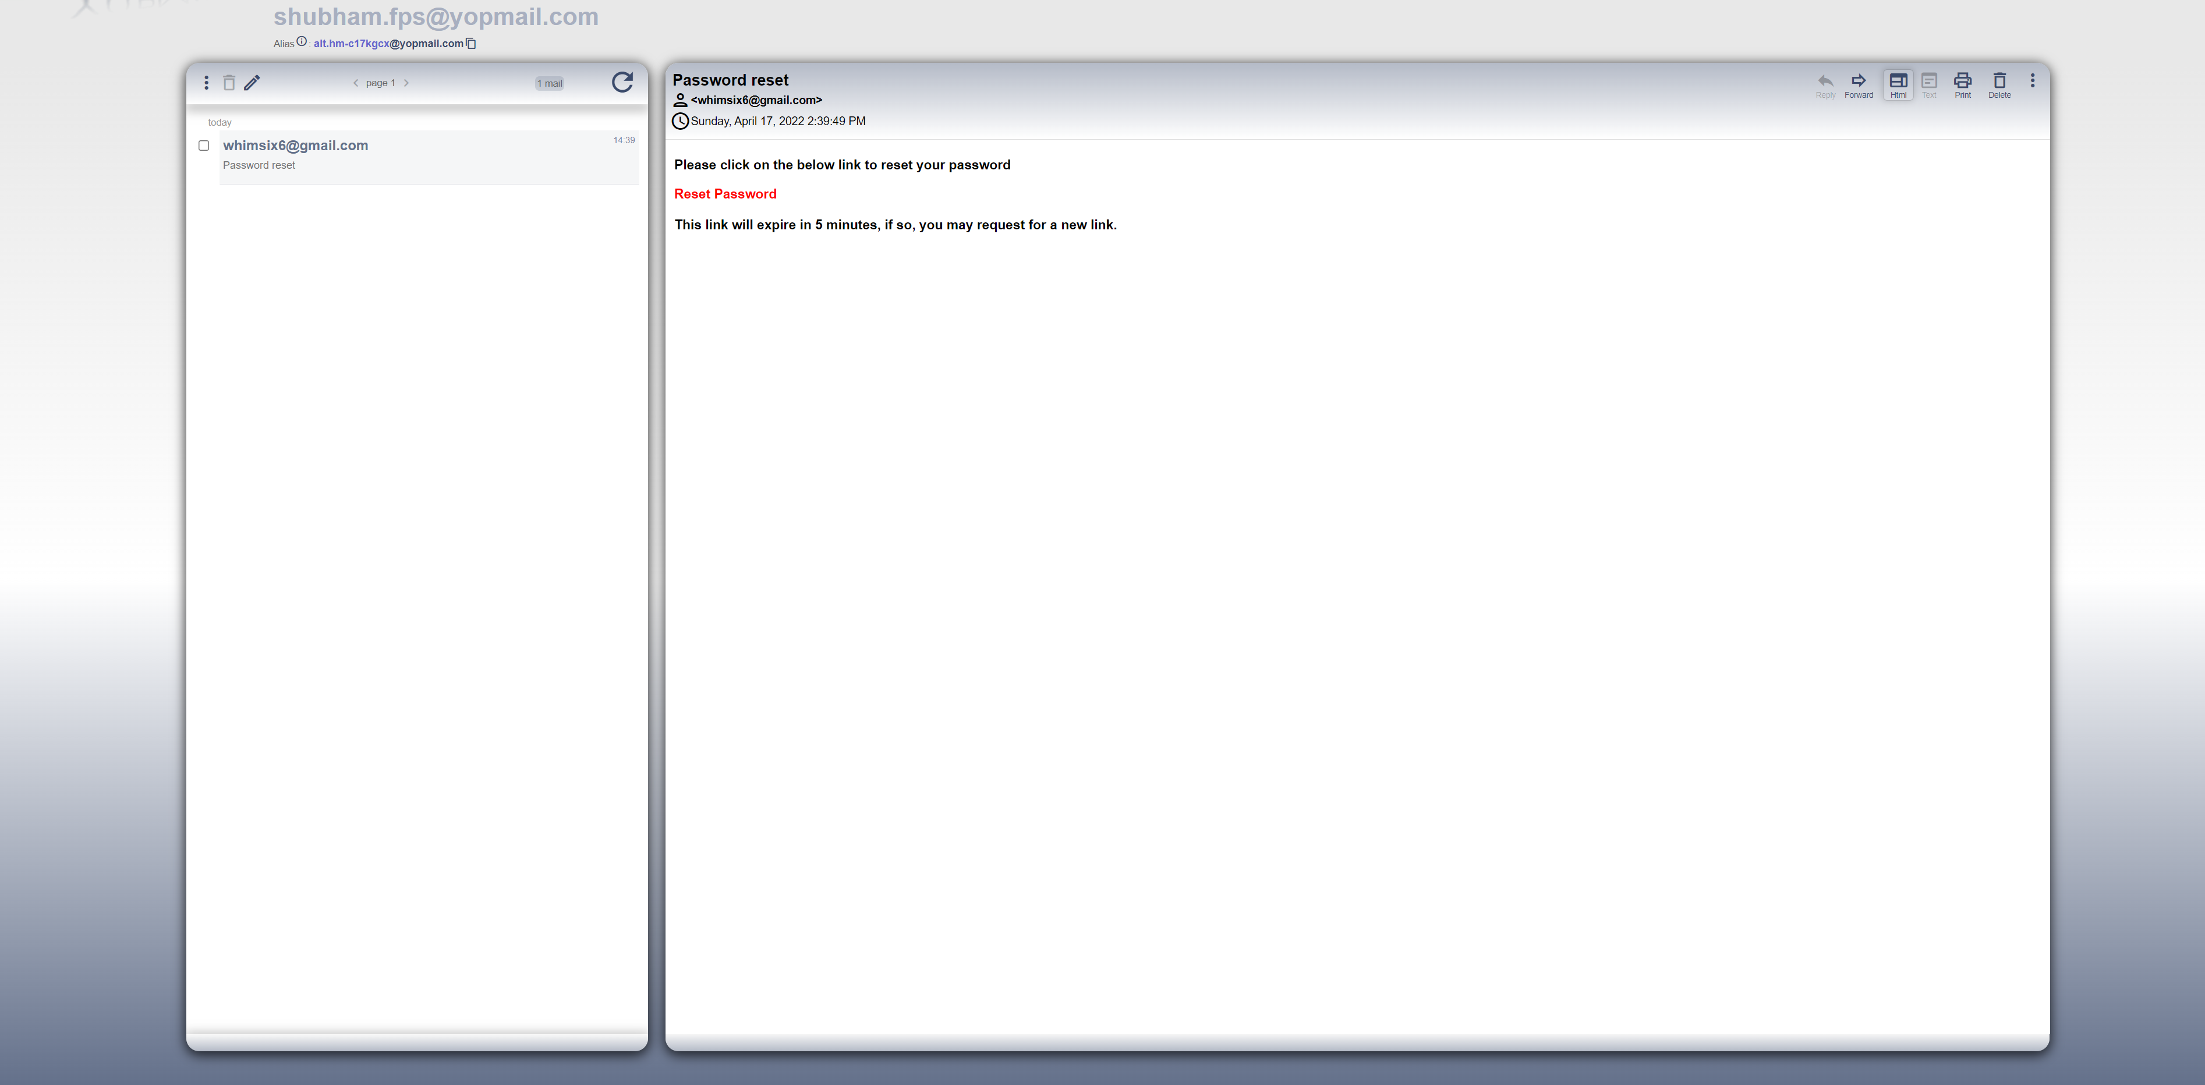

By clicking the reset password hyperlink it will take the user to update password page of the application.

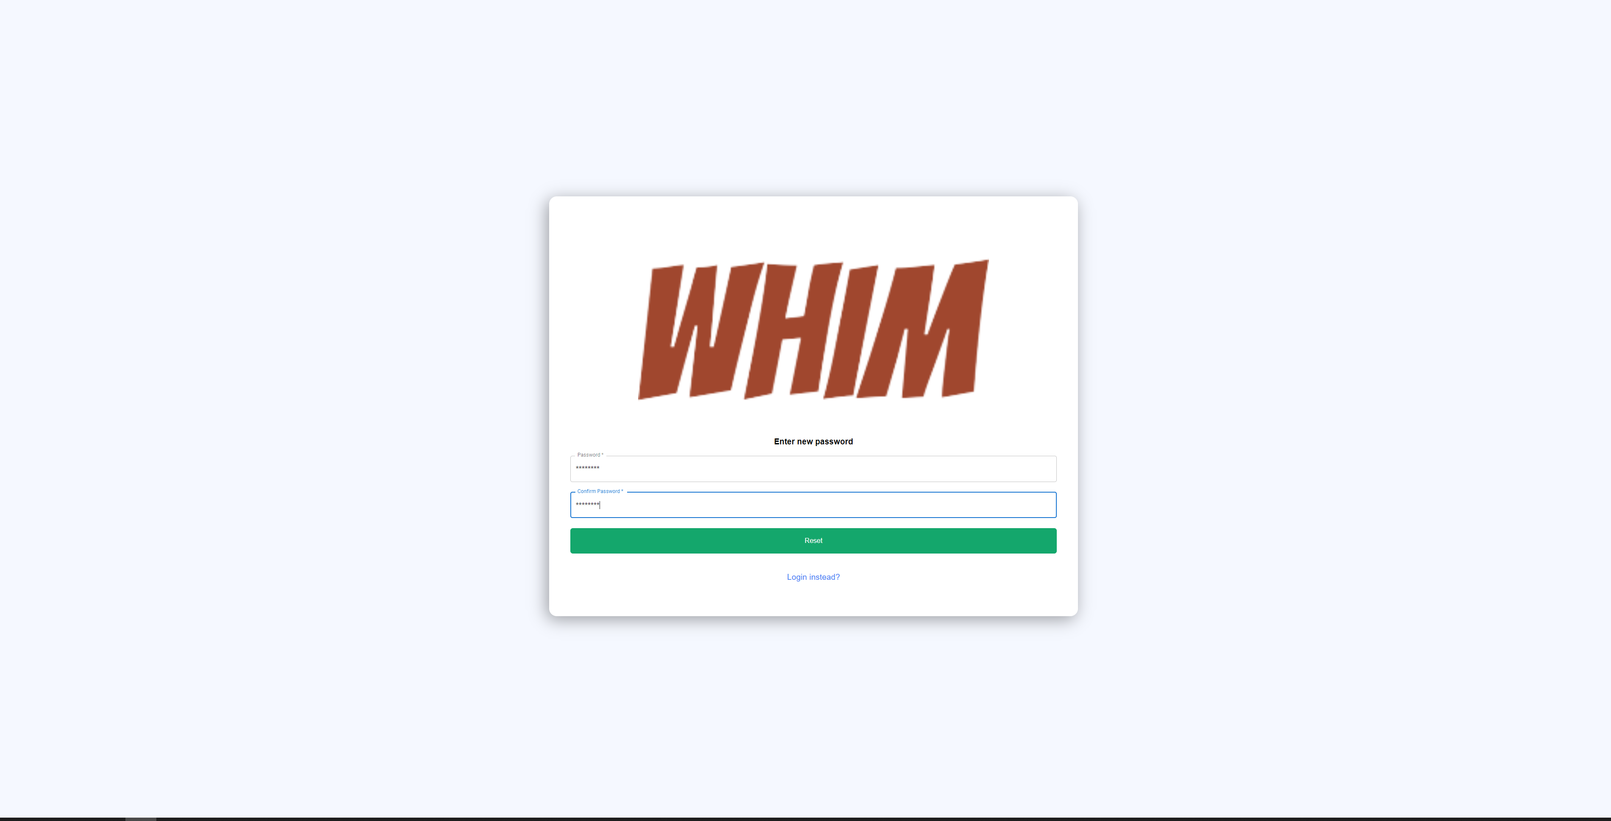

User can set the new password with the help of this feature.

**c.Updating your Profile**

With the help of the My Account feature user can update his profile introduction, Description, Profile picture etc.

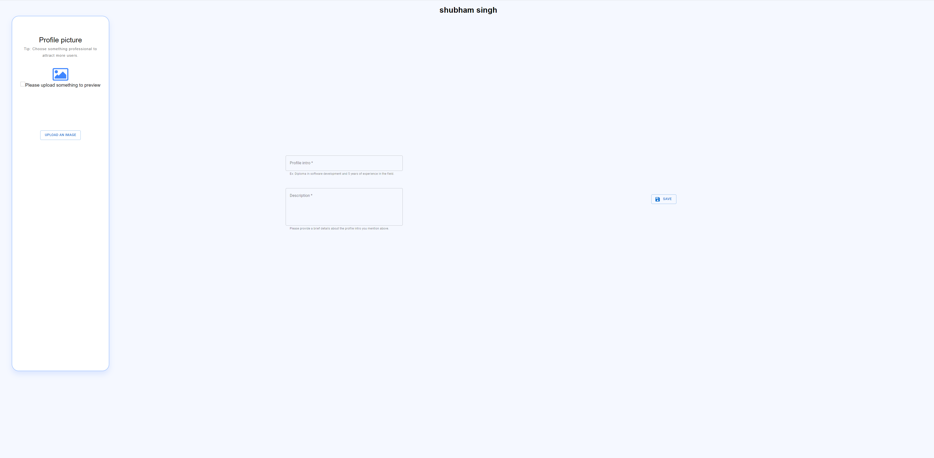

**d.Subscription**

User can choose the subscription option from the list as per their choice.

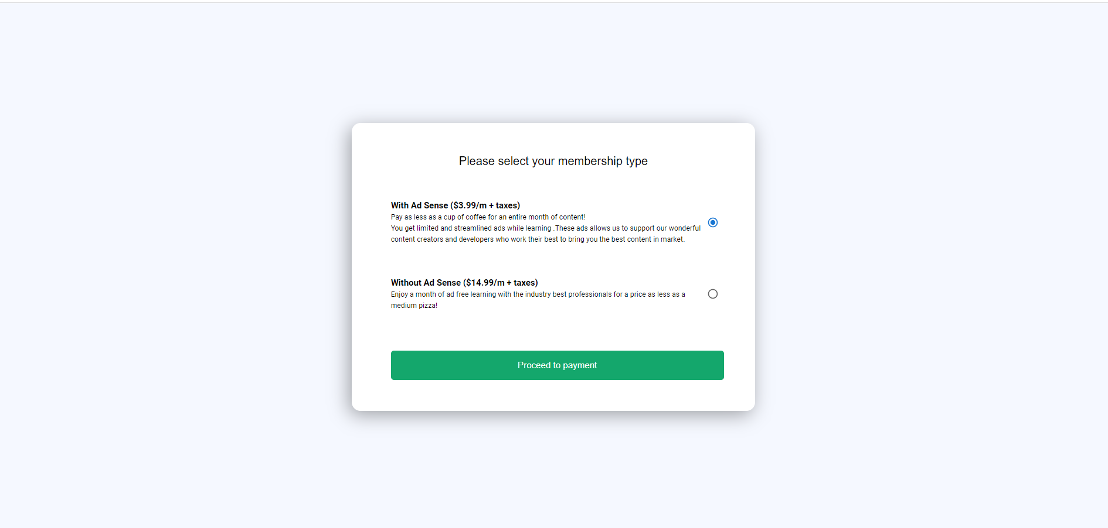

**i.Checkout**

User can checkout with the help of credit card payment

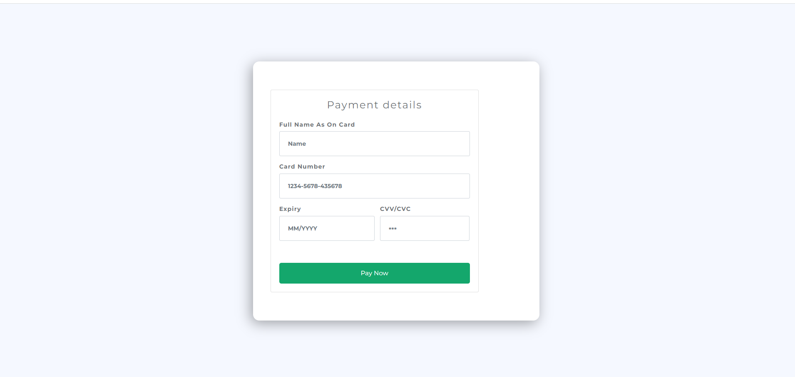

**ii.Payment confrimation**

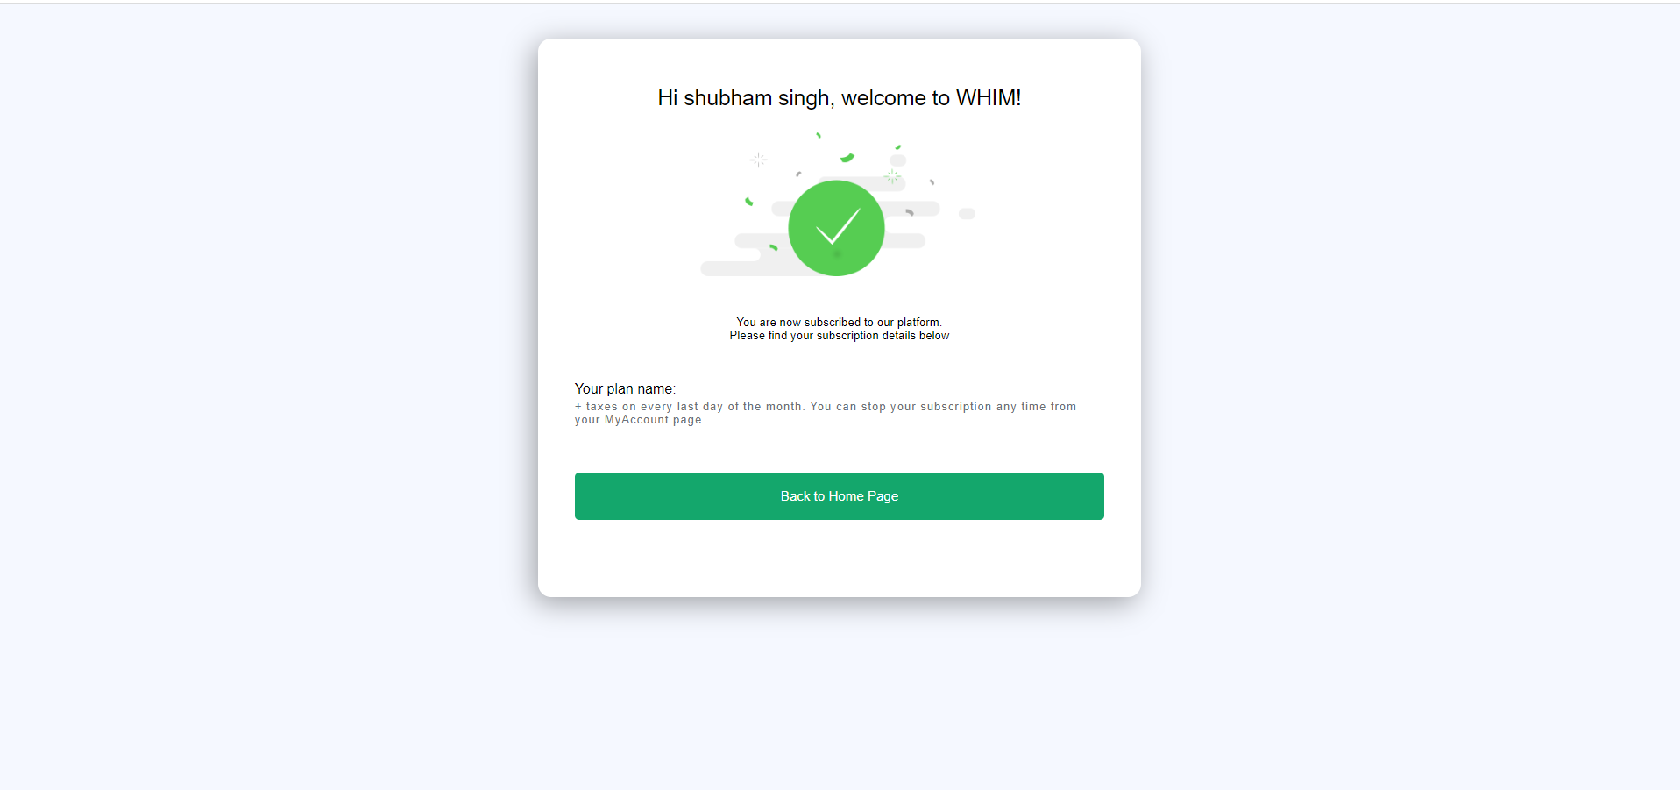

**e.Post Hobby**

Author will have the option to post hobbies.

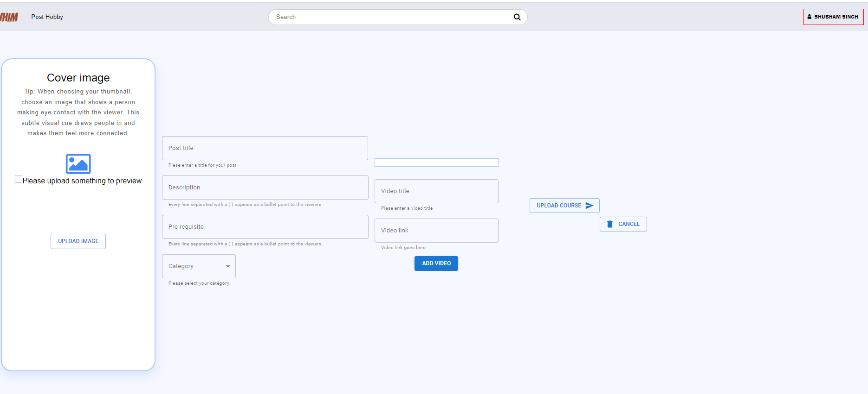

**4.Conclusion**

The best part of Whim, it will have a vast variety of content to target every age group. E-learning courses are always affordable than a physical book and is sustainable as it does not need paper or ink.

*Created with the Personal Edition of HelpNDoc:* [*Easily create EPub books*](https://www.helpndoc.com/feature-tour)